urban enterprise zone: area offering special tax incentives to businesses locating within its boundaries.
-100-
GLOSSARY
Utopian socialists: creators of small, ideal communities in which factories were owned by the workers and profits shared by all.

V
value-added tax (VAT): tax levied on the value added to goods at every stage of production.
variable costs: costs that increase as the number of units produced increases.
variable expense: expenses that increase or decrease with the volume of business.
velocity: the number of times that the money supply is spent in a year; the speed at which money circulates.
venture capital: money available for high-risk investments.
vertical merger: combination of companies involved in different steps of the same production process; also called vertical integration.

W
wages: the price paid for the use of labor. (To the economist, the term refers to the nation's wealth paid to labor, as distinct from other forms of income-rent, interest, and profit.)
wampum: a form of money used by Native Americans.
water pollution: water is considered polluted when it cannot be used for its intended purpose.
wealth: the total value of one's tangible assets.
World Bank: officially, the International Bank for Reconstruction and Development, the bank is an international agency that makes loans to less-developed countries as a way of stimulating economic growth.

Y
yellow-dog contract: agreement signed by workers in which they promise not to join a union. Outlawed by the Norris-LaGuardia Act.
yield: actual amount of interest earned; depends on the rate of return and the frequency of compounding.

Chapter 1
-3-
WHAT IS ECONOMICS?
_______________________________________________________________
Overview:
As you read this chapter look for answers to the following questions:
- Why must all societies deal with scarcity?
- Why is economics sometimes called the "study of scarcity and choice"?
- What are trade-offs and opportunity costs?
- Why should everyone understand basic economics?
- What are the factors of production?
- How do different economic systems solve the problem of scarcity?
_______________________________________________________________

Scarcity.
One of the things that young people discover as they grow older is that you can't have everything. You are reminded of it every time you shop. Although you may see twenty or thirty items that you would really like to buy, you know that you will have to limit your selection to one or two. Everyone goes through life having to make choices.
Every business, even sports teams, must pick and choose from among the things they would like to have because, like you and me, they cannot have everything.
Governments, too, cannot have everything. Every year the most important political debates concern questions about spending taxpayers' money.
Neither individuals nor societies can have all the things they would like to have. There simply is not enough of everything to go around. Economists note that there is no limit to the amount or kinds of things that people want. There is, however, a limit to the resources, things used to produce goods and services, available to satisfy those wants. Once that limit is reached, nothing else can be produced.
In other words, when a nation's resources (all its workers, factories, farms, etc.) are fully employed, the only way it will be able to increase the production of one thing will be by reducing the production of something else. This happened during World War II. In its efforts to increase the production of tanks and other military vehicles, our nation's factories stopped producing automobiles. Therefore, if somebody tries to sell you a 1944 Ford or Chevrolet, run, do not walk, to the nearest exit-none were produced that year.
To summarize: human wants are unlimited, but the resources necessary to satisfy those wants are limited. Thus, every society is faced with the identical problem, the problem of scarcity.

Economics:
-4-
The Study Of Scarcity And Choice.
Since there is not enough of everything to go around, everyone-individuals, business firms, and government-needs to make choices from among the things they want. In the process they will try to economize, to get the most from what they have. With this in mind, we can define economics as the social science that describes and analyzes how society chooses from among scarce resources to satisfy its wants.
The need to choose is imposed on us all by our income, wealth and ability to borrow. Individuals and families are limited by the size of their personal income, savings and ability to borrow. Similarly, business firms are limited by their profits, savings and borrowing power, and governments by their ability to tax and borrow.
Income, savings, profits and taxes enable people, institutions and government to purchase goods, products you can see or touch, and services, work performed for pay that benefits others. The problem that each must face, however, is that once the decision has been made to choose one set of alternatives, one loses the opportunity to choose the other.

Trade-Offs And Opportunity Costs.
Let's suppose that you recently managed to save enough to buy the CD player you always wanted. While you were building up your savings, you discovered the fun of basketball and would now love a pair of pump sneakers. You can afford to buy either a CD player or sneakers, but not both. It's a trade-off.
Economists describe these kinds of trade-offs as opportunity costs. The opportunity cost of something is its cost measured in terms of what you have to give up to get it. Thus, the opportunity cost of the CD player in the example above would be new sneakers.
Business is also faced with the problem of choices and opportunity costs. In planning an advertising program, for example, a local store might have to choose between a newspaper ad or a direct-mail campaign. If it puts its efforts into newspaper advertising, the opportunity cost is the benefits of a direct-mail campaign.
Like individuals and business firms, government also pays opportunity costs. If, for example, the federal government chooses to increase its spending for roads by reducing the number of warships to be built, the opportunity cost of the improved road network would be a more powerful navy.

Why Study Economics?
By now you may be asking yourself, "Why should I study economics?" There are several very good reasons, all of which involve you. Some have to do with

T
-99-
GLOSSARY
tariff: a tax or duty on imports.
tax base: the money, property and people on whom taxes could be levied.
tax incidence: the final effect of a tax; who will really have to pay the tax.
technological revolution: refers to a relatively sudden change resulting from the introduction of new products or processes.
technology: the application of science to commerce and industry.
testimonials: advertisements in which a famous person claims that he or she uses and enjoys a particular product.
thrift institutions: savings and loan associations, mutual savings banks and credit unions.
trade loans: credit extended by vendors to their customers.
trademarks: special designs, names or unique symbols that identify a product, service or company.
trade-off: giving up one thing in order to obtain something else.
traditional economy: an economic system that allocates scarce resources according to custom; change and growth are very slow; people do what their parents did before them; and most goods are produced and consumed locally.
transfer payments: payments that represent a redistribution of wealth, such as Social Security benefits, pensions, welfare, rather than an exchange for goods or services.
travelers' checks: checks sold by certain banks and specialized firms (such as American Express) that are refundable if lost or stolen.
Treasury bills: securities of the federal government issued for terms of less than a year. The purchasers are lending money to the government.
trust: an arrangement whereby a bank provides safekeeping and management of funds for individuals, estates or institutions such as pension funds. The term also refers to a specific form of monopolistic practice, and sometimes to monopoly in general—as in "antitrust law."

U
underground economy: exchanges of goods and services not reported to the IRS for tax purposes.
underwrite: to assume risk, as in the case of those who underwrite the sale of securities by purchasing an entire issue from the corporation and marketing it on their own.
unemployment rate: indicator of economic activity that compares the number of people in the labor force to the number looking for work; percentage of the labor force unable to find jobs.
union shop: allows nonunion workers to be hired on condition that they join the union.
unit cost: the cost of producing an item;
determined by dividing total costs by the number produced.
United States savings bonds: small-denomination certificates issued by the U.S. government for relatively long terms; purchasers are lending money to the government.
unlimited liability: requirement that the owner or owners assume full responsibility for all losses or debts of a business.
urban community: one in which 50,000 or more people live in a central city and its surrounding suburbs.

S
sales tax: a regressive tax added to the price of goods at the time they are sold.
-98-
GLOSSARY
savings institution: financial institution that holds personal savings for safekeeping and pays interest.
scarcity: a limit to the supply of productive resources or consumer goods in relation to producers' or consumers' demand for them.
S corporation: business organization that enjoys the advantages of the corporation without being subject to corporate taxes.
security exchange: market where brokers meet to buy and sell stocks and bonds.
Securities and Exchange Commission (SEC): Federal agency charged with protecting the public against wrongdoing in the sale of securities.
seniority: the importance assigned to a worker's length of service when it comes to questions of raises or layoffs, etc.
service industries: businesses which provide services, such as health care, legal advice or appliance repair.
services: intangible items of value, such as the work of physicians, lawyers, actors or mechanics.
Sherman Antitrust Act: a law passed by Congress in 1890 that prohibits monopolies or any business combination that restrains trade.
short-term credit instruments: notes and other IOU's that come due in a year or less.
short-term loans: loans that must be repaid in a year or less.
slogans: words or phrases used in advertising that sound great but mean lime or nothing.
socialist economy (socialism): economic system in which the principal means of production are owned by the state, and resources are allocated by central planning.
sole proprietorship: a business that is owned by one person.
specialization: production of a limited variety of products by a business, region or country.
standard of living: a measure of the amount of goods and services an individual or group considers essential.
stock: share in the ownership in a corporation.
stockholder: owner of stock in a corporation.
strike: work stoppage to pressure management to accept union demands.
structural unemployment: unemployment resulting from changes in technology, consumer preference or movement of jobs from one region to another.
subsidy: financial aid.
subsistence level: the level of income necessary to maintain a minimum standard of living; any less will result in hunger and disease.
supply: refers to the number of items that sellers will offer for sale at every price at a particular time and place.
supply schedule: a table showing the quantities of a product that would be offered for sale at various prices at a given time.
surplus: excess of revenues over expenditures.
you as an individual, some with you as an earner and spender, and some with you as a citizen.
-5-
As a member of the society in which you live, there is no escaping economics. The food you eat, the home you live in, the clothes you wear, and the way you spend your leisure time are all affected, in part, by economic forces. The study of economics will help you to understand these forces better and enable you to live a fuller life.
Economic forces also affect decisions in the world of business. In fact, one common definition of economics is "the study of how people make a living. The more you know about the subject, the better career decisions you will be able to make.
Economics will also help you to fulfill your responsibilities as a citizen in a democracy. Unlike other countries, in which government officials or dictators assume sole control over the nation's affairs, the United States expects its citizens to share in governing the country. As a voter, you will be asked to express your opinion on many questions involving economic issues. The study of economics will help you deal with these questions intelligently.

What Do Economists Do?
We have seen that economics deals with the problems of scarcity and choice that have faced societies and nations throughout history, but the development of modern economics began in the 17th century. Since that time economists have developed methods for studying and explaining how individuals, businesses and nations use their available economic resources. Large corporations use economists to study the ways they do business and to suggest methods for making more efficient use of their employees, equipment, factories, and other resources. The United States government also employs economists to study economic problems and to suggest ways to solve them.
You will discover that economists deal with two worlds: the ''world that is,'' and the ‘’world that ought to be.'' Economists have developed and generally agree on basic economic principles and models that try to explain or describe the "world that is." An economic model is any simplified statement, diagram, or formula used to understand economic events. For example, economists can use basic principles like the laws of supply and demand and simple economic models to predict that the price of coffee in the United States will go up after a freeze destroys much of the Brazilian coffee crop. All economists would agree that the freeze would result in a price increase, but predicting the size of the increase would depend on the quality of the economist's model. As you travel through this semester of Applied Economics, you will learn to use several economic models which will help you understand and analyze economic events.
In many cases, however, economic issues cannot be solved with theories and models alone. Solutions to these problems involve opinion, politics, and personal values. For example, what ought to be done about the high rate of teenage unemployment? Economists will agree that unemployment is bad. As a solution to that problem, one economist might propose that government create jobs for teenagers. Another will oppose this step, suggesting instead that the problem of teenage unemployment would be solved if employers were allowed to pay teenagers lower wages than they must pay adult workers.
-6-

Microeconomics vs. Macroeconomics.
Economists have two ways of looking at economics and the economy. One is the macro approach, and the other is the micro. Macroeconomics is the study of the economy as a whole; microeconomics is the study of individual consumers and the business firm.
Macroeconomics examines questions such as how fast the economy is running; how much overall output is being generated; how much total income. It also seeks solutions to macroeconomic problems such as how employment can be increased, and what can be done to increase the output of goods and services.
Microeconomics examines cause-and-effect relationships that influence choices of individuals, business firms and society. It is concerned with things such as scarcity, choice and opportunity costs, and with production and consumption. Principal emphasis is given by microeconomists to the study of prices and their relationship to units in the economy.

Factors Of Production.
The resources that go into the creation of goods and services are called the factors of production. The factors of production include natural resources, human resources, capital and entrepreneurship. Each factor of production has a place in our economic system, and each has a particular function. In the American economic system people who own or use a factor of production are entitled to a "return or reward." This generates income which, as it is spent, becomes a kind of fuel that drives the economy.
Natural Resources or "Land." Natural resources are the things provided by nature that go into the creation of goods and services. They include such things as mineral, wildlife and timber resources, as well as the air we breathe. Our country has been especially rich in natural resources. Economists also use the term "land" when they speak of natural resources as a factor of production.
- The price paid for the use of land is called rent. Rent becomes income to the owner of the land.
Human Resources or "Labor." Economists call the physical and mental effort that people put into the creation of goods and services labor.
proxy: a written authorization transferring voting rights to another at a stockholders' meeting.
-97-
GLOSSARY
public utilities: privately owned firms that provide an essential public service and are subject to government regulation.
purchasing power: value of money.

Q
quality circles: small, voluntary groups of employees who meet regularly to identify and solve work problems.
quality control: maintaining acceptable and dependable levels of quality in production.
quotas: restrictions on the number of goods that can enter the country from abroad.

R
rate of exchange: the price at which a particular currency sells in terms of other currencies.
rate of inflation: annual percentage increase in the general level of prices.
rate of return: the amount of interest or dividends stated as a percentage of the principal of an investment.
rational appeals: rely on logic or reason to convince the consumer to buy a product.
real GNP: GNP adjusted for changes in the price level; the value of goods and services produced in the nation in a given year.
recession: the bottom of the business cycle;
a period of low business activity and high unemployment.
regressive tax: one that takes a higher percentage of a low income and a lower percentage of high income.
rent: return paid to those who supply the factor of production known as land.
research and development (R&D): activity directed toward discovering new products and processes.
reserve ratio: the proportion of a bank's deposits that must be kept on reserve at the Federal Reserve bank or in its own vaults.
reserves: fixed portion of bank's deposits that cannot be loaned.
resources: anything used as an input in the creation of goods and services.
retained earnings: undistributed profits, often used to finance major projects.
revenue tariff: tax on imports designed to raise money for the government (see protective tariff).
right-to-work laws: state laws guaranteeing individuals the right to hold a job without being required to join a union. Right-to-work laws have been enacted in: Alabama, Arizona, Arkansas, Florida, Georgia, Idaho, Iowa, Kansas, Louisiana, Mississippi, Nebraska, Nevada, North Carolina, North Dakota, South Carolina, South Dakota, Tennessee, Texas, Vermont, Virginia, and Wyoming.
rural community: one in which there are fewer than 2,500 residents and one that is far from any urban community.
physiocrats: Thinkers in 18-century France who believed that because natural resources were the true source of wealth, it made little sense for government to promote business.
picketing: effort by unions to inform the public of a labor dispute by parading in front of their workplace with signs listing their grievances.
-96-
GLOSSARY
political action: refers to the effort by labor unions to enlist the support of government and politicians for their programs.
popularity appeal: suggestion that simply using the advertised product will make you popular.
preferred stock: stock that receives a specified dividend before any dividends are paid on common stock and that receives a share of the assets of a liquidated corporation ahead of common stockholders.
price: the money value of a good or service.
price discrimination: practice of selling the same product for less to one company than to another.
price stability: the absence of inflation or deflation—a period of time in which there is little change in what the dollar can buy.
price system: economic system in which resources are allocated as a result of the interaction of the forces of supply and demand.
-7-
principal: the amount borrowed.
private property: basic right of the free enterprise system that guarantees the individual's right to own, use, and dispose of things of value.
producer co-ops: manufacturers and marketers of products on behalf of their members.
product: the good or service one receives in an exchange.
product differentiation: process of creating uniqueness in a product.
product labeling: attaching to a product statements identifying its contents and use.
production-possibilities curve: a curve showing the possible combinations of total output that could be produced if a nation's resources were fully employed.
productive capital: things used to produce goods and services; machines, tools, factories, equipment, etc.
productivity: the output of goods and services as measured per unit of time, or per person, per company, per industry, or for the whole economy.
profit: what remains after the costs of doing business have been met. Difference between a firm's total revenues and its total costs.
profit-and-loss statement: summary of a firm's revenue, costs and taxes over a period of time.
profit margin: difference between cost and selling price.
profit motive: the desire to benefit from the investment of time and money in a business enterprise.
progressive tax: one that takes a larger percentage of a higher income and a smaller percentage of a lower income.
promotion: program designed to sell goods or services to the public.
proportional tax: one that takes the same percentage of all incomes regardless of size.
prospectus: a statement containing pertinent financial information published when a corporation is about to issue new securities.
protective tariff: tariff levied to protect a domestic industry from foreign competition (see revenue tariff).
- The price paid for the use of labor is called wages. Wages represent income to workers, who own their labor.
Capital. To the economist, physical capital (or "capital" as it is commonly called) is something created by people to produce other goods and services. A factory, tools and machines are capital resources because they can be used to produce other goods and services. So too is the truck that delivered gasoline to the local service station. The term capital is often used by business people to refer to money they can use to buy factories, machinery and other similar productive resources.
- Payment for the use of someone else's money, or capital, is called interest.
Entrepreneurship. Closely associated with labor is the concept of entrepreneurship, the managerial or organizational skills needed by most firms to produce goods and services. The entrepreneur brings together the other three factors of production. When they are successful, entrepreneurs earn profits. When they are not successful, they suffer losses.
- The reward to entrepreneurs for the risks, innovative ideas and efforts that they have put into the business are profits, whatever remains after the owners of land, labor and capital have received their payments.

The Basic Economic Problem.
The central problem of economics is to determine the most efficient ways to allocate the factors of production and solve the problem of scarcity created by society's unlimited wants and limited resources. In doing so, every society must provide answers to the following three questions:
- What goods and services are to be produced, and in what quantities are they to be produced?
- How are those goods and services to be produced?
- Who will receive and consume (get to use) those goods and services?
Let us take a closer look at each of these basic economic questions.
What Goods and Services Are to Be Produced and in What Quantities Are They to be Produced? Individuals and societies can obtain things by producing them themselves, exchanging things that they already own for them, or receiving them as gifts. Since a society cannot have everything, it must decide which goods and services it will have now and which ones it is willing to postpone having or give up completely. For example, there are those who say that the United States should put more of its efforts into improving production of basic commodities, such as automobiles and steel. They wish to prevent the further loss of trade to competitors such as the Japanese. In order to achieve this goal, they urge our nation to devote more effort to developing basic goods and services rather than luxury items.
Sometimes the choices can be quite difficult. For example, there are nations today, known as less-developed countries (LDC's), that are so poor it takes the effort of most of their labor force just to feed and clothe their people. For such a society to raise its living standards it would be necessary to increase production beyond present levels. But if everyone in the country is already working at a full-time job, how can total production be increased?
-8-
One way to increase total production in the future would be to modernize. This might require shifting workers out of the production of food and clothing and into the production of additional capital such as machines, tools and factories. To do so, however, would mean that less food and clothing would be produced for present use in order to increase output some time in the future. For a nation with large numbers of people living in poverty even the slightest reduction in the food supply could trigger widespread hunger. Fortunately, there are many international agencies and generous nations, such as the United States, that have provided aid to the LDC's, helping them modernize while feeding their people.
How Are Those Goods and Services to be Produced? There is more than one way to build a home or a school, manufacture an automobile, or farm a piece of land. Will the school consist of many stories or one floor? Will the automobile assembly line use robots? How much farmland will be used for corn and how much for wheat?
With the exception of the school building, which in most instances would be a government project, all these questions would be answered in this country by private individuals. In other parts of the world, however, how to manufacture an automobile might well be a decision made by the government. As for farming practices, some societies leave that to government to decide, others follow long-honored traditions, while in still others the farmer decides.
Who Will Get to Use the Goods and Services Produced by the Economy? Since there will not be enough produced to satisfy everybody's wants, some way will have to be devised to determine how the output is divided. Who, for example, will get to ride in limousines; who will have to use public transportation; and who will have to walk?
Society has answered these questions in many ways. In some countries those of noble birth are entitled to a larger share of the nation's output than others. In other countries membership in a particular political party has been the key to wealth.
Here, in the United States, the market system and the ownership of wealth are the key elements in determining who will be rich, middle class or poor.

near monies: assets that are easily turned into cash.
-95-
GLOSSARY
negotiable order of withdrawal (NOW) accounts: interest-bearing accounts on which the depositor is entitled to write checks.
net exports: the difference between total exports and total imports over the course of a year.
net interest: an item in the federal budget representing the difference between the interest earned by the government on its investments and the interest it must pay on its debts.
net worth: the difference between a firm's assets and its liabilities.
nonprice competition: methods other than selling-price changes used by firms to compete with one another.
notes payable: short-term loans owed by the corporation.
not-for-profit corporation: one that has been organized to serve some particular educational, social, charitable or religious purpose rather than to earn a profit.

O
oligopoly: market dominated by a few large firms.
OPEC (Organization of Petroleum Exporting Countries): a cartel of crude-oil producing countries formed to regulate the production and prices of petroleum on international markets.
open (or public) corporation: one whose stock is sold to the public.
Open Market Committee: agency of the Federal Reserve that regulates the nation's money supply.
open-market operations: refers to the purchase and sale of government securities by the Fed's Open Market Committee.
open shop: a business open equally to union and nonunion workers.
opportunity cost: the amount of goods and services that must be given up in order to obtain other goods and services.
output per worker per hour: terms in which productivity is usually measured.
over-the-counter market: brokerage firms around the nation that buy and sell securities of smaller firms not listed on the large exchanges.
overhead costs: fixed costs of doing business.

P
partnership: unincorporated business organization owned by two or more persons.
passbook and statement savings accounts: savings accounts offering ease of withdrawal, safety of principal, and low interest rates.
patent: a monopoly to use a new product or idea exclusively for 17 years.
peer review panels: committees made up of management and labor representatives who listen to worker grievances and rule on them.
per capita real GNP: GNP adjusted for changes in average prices and divided by the population; a figure showing the amount of real goods and services per person produced in the nation in a given year.
perfect competition: a market for uniform products in which there are many buyers and sellers, no one of which is big enough to affect the price, and full knowledge of market conditions.
M2: a broader definition of the U.S. money supply; includes all of Ml plus savings and time deposits of less than $100,000, money-market deposit accounts, and shares of money-market mutual funds held by households and small businesses.
M3: broader definition of money;
-94-
GLOSSARY
includes all of M2 plus deposits of $100,000 or more and shares of money-market mutual funds that are used by large institutions and corporations.
macroeconomics: the study of the economy as a whole.
market: place where buyers and sellers come together.
market economy: an economic system in which national economic decisions are the result of decisions by individual buyers and sellers in the marketplace.
marketing: the business activities that take place between production and consumption.
marketplace: any place in which goods are bought and sold.
market price: price at which goods or services and money will actually be exchanged. The price at which supply exactly equals demand.
mass production: the production of goods and services on a large scale, using division of labor and machinery or technology.
mediation: method for settling labor disputes in which a third party makes non-binding suggestions.
mercantilists: Some of the first modem economists who believed that nations should behave like merchants competing with one another; they wanted government support to keep the nation's businesses competitive.
merger: combination of previously separate firms into one.
microeconomics: the study of the individual parts of the economy, with special attention to the market process and how it works.
minimum wage laws: establish the lowest legal wage that an employer can pay.
mixed economy: economic system that combines elements of public ownership of the means of production with private ownership.
monetary policy: use of the Federal Reserve's power to control the supply of money and credit to influence economic activity in the nation as a whole, particularly to control inflation and stimulate economic growth.
money: can be anything that is generally accepted in payment for goods and services.
money market: market for short-term credit instruments such as Treasury bills.
money-market funds: mutual funds that use the resources of their investors to buy money-market certificates.
monopolist: seller who controls the supply of a good or a service.
monopolistic competition: a market in which many firms are selling similar (but not identical) products.
monopoly: market in which there is only one seller.
mortgage: a long-term loan usually used to finance a building.
mutual funds: corporations that sell stock and use the proceeds to invest or speculate in the securities markets.

N
nationalization: government takeover of a privately owned industry.
natural resources (land): the things provided by nature that go into the creation of goods and services.
Types Of Economic Systems.
-9-
Every society has worked out a way to answer the questions of What, How and Who. These economic systems, as they are called, generally fall into one of three categories: traditional, command and market economies.
The Traditional Economy. As the name implies, the answers to the What, How and Who questions are decided by tradition in these economies.
Traditional economic systems are usually found in the more remote areas of the world. Such systems may characterize isolated tribes or groups, or even entire countries. They are less common today than they were in earlier decades. Typically, in a traditional economy, most of the people live in rural areas and engage in agriculture or other basic activities such as fishing or hunting. The goods and services produced in such a system tend to be those that have been produced for many years or even generations. They are produced as they always have been. In short, the questions of what the traditional society produces and how it is produced are determined by very slowly changing traditions.
Who gets to keep what is produced in such an economy? Since there is little produced, there is little to go around. Most individuals live near a subsistence level: They have enough to sustain them but little more than that. In some years, when the harvest is poor, some will not be able to subsist and will either leave the society or die. In better years, when the yield is high, there may be more than enough to allow subsistence. When such a surplus exists, it will be distributed traditionally. For example, the bulk of the produce might go to a tribal chief or large landholder, while the balance is distributed according to custom.
The Command Economy. Countries such as Cuba, North Korea, and China are examples of command economies. Groups of high-level technicians, made up of engineers, economists, computer experts and industry specialists known as "planners," advise political leaders who develop and implement a plan for the entire economy.
Essentially, it is the planners who decide what goods and services will be produced. If they want ship production expanded and mining operations cut back, they issue the orders to do so. If more food is needed, the planners might direct tractor production to be increased or fertilizers to be imported from the West. Those same plans might also encourage labor to remain on the farms and direct that transportation and storage facilities be made available to move and hold farm products.
How are goods produced in a command economy? The planners decide which products will be made. They decide where to locate a new truck assembly plant and whether the factory will use more labor or more modem machinery.
It is the planners, too, with guidance from the country's political leadership, who decide who will receive the goods and services produced. By setting wage rates for everyone, as well as interest rates, profits and rents, the planners directly answer the question: Who will receive the goods and services produced?
The Market Economy.
-10-
When the fastest-rising young rock group, the And-So-Forths, appeared recently in a televised concert, they wore old-fashioned saddle shoes. That week shoe stores around the country reported receiving calls for saddle shoes "like the And-So-Forths wear." Although some of the storekeepers thought the first customers to ask for the strange shoe style were joking, they soon got the message. Before long, saddle shoes could be seen in most of the nation's shoe stores.
The events described in the paragraph above probably would not have taken place in a traditional or a command economy. Changes in clothing styles in a traditional society could occur only over a period of many years. Those who make the decisions in a command economy might give in to public pressure and produce saddle shoes, but it is their decision to make. In a market economy, or free enterprise system as it is sometimes called, it is likely that if consumers really want saddle shoes, they will get them.
A market, or free enterprise, economy is one in which the decisions of many individual buyers and sellers interact to determine the answers to the questions of What, How and Who.
In addition to buyers and sellers, there are several other essential elements in a market economy. One of these is private property. By "private property" we mean the right of individuals and business firms to own the means of production. Although markets exist in traditional and command economies, the major means of production (firms, factories, farms, mines, etc.) are usually publicly owned. That is, they are owned by groups of people or by the government. In a market economy the means of production are owned by private individuals. Private ownership gives people the incentive to use their property to produce things that will sell and earn them a profit.
This desire to earn profits is a second ingredient in a market economy. Often referred to as the profit motive, it provides the fuel that drives sellers to produce the things that buyers want, and at a price they are willing to pay.
The profit motive also gives sellers the incentive to produce at the lowest possible cost. Why? Because lower costs enable them to (1) increase their profit margins, the difference between cost and selling price, or (2) reduce prices to undersell the competition, or (3) both.
Economists often compare markets to polling booths. However, unlike the booths in which people vote for politicians, markets provide a kind of economic polling booth for buyers to cast their votes (in the form of purchases) for the goods and services they want. Producers who interpret the votes correctly by producing the things that buyers demand can earn profits. Those
International Monetary Fund (IMF): an agency that lends foreign exchange to LDC's and other member nations.
-93-
GLOSSARY
inventory: stock of goods held by a business.
investment: using money to purchase real capital (equipment, new tools, industrial buildings) to be used in the production of goods and services.

J
job discrimination: practice of favoring one group over another in hiring, salary or promotion for reasons that have nothing to do with ability.

L
L: the broadest definition of the U.S. money supply. Includes everything found in the other definitions (see Ml, M2 and M3) plus U.S. savings bonds, Treasury bills, and other credit instruments.
labor: the human effort required to produce goods and services.
laborer: generally refers to unskilled workers, such as freight handlers, sweepers, trash collectors and the like.
labor force: consists of all those people 16 years of age or older who are currently employed or are looking for work.
labor unions: associations of workers formed to promote the interests of their members.
laissez faire: French term meaning "let them do"; describes a policy of minimal involvement of government in business.
law of demand: all else being equal, more items will be sold at a lower price than at a higher price.
law of diminishing returns: as variable inputs are applied to the fixed input, output will increase at first. But, if the process is continued, a point will be reached (the point of diminishing returns) at which output per unit of input will begin to decrease.
law of supply: sellers will offer more of a product at a higher price and less at a lower price.
legal monopoly: right to be the sole provider of a good or service, such as public utilities, patents and copyrights.
legal tender: currency accepted in payment of debt.
less-developed countries (LDC'S): countries in which per capita real income is much lower than in industrialized nations.
liability: any claim on, or debt of, a business or individual.
limited liability: advantage of a corporation allowing a stockholder no legal responsibility for its debts beyond the sum he or she has invested in the corporation.
liquidity: the ease with which savings or other assets can be converted to cash.
lockout: suspending business and wages to pressure a union to accept management's terms.
long-term loans: loans that mature (come • due) in more than a year.

M
Ml: the narrowest definition of the U.S. money supply; includes currency in circulation, demand deposits, other checkable deposits, and travelers checks.
grants-in-aid: money given by the federal government to state and local governments for a specific purpose.
Great Depression: the worst depression in American history, lasting from 1930-1940.
-92-
GLOSSARY
grievance procedures: procedures that employees follow if they feel they have been treated unfairly.
gross domestic product: total value of the goods and services produced within a country in a single year.
gross national product (GNP): a measure of the nation's total output of goods and services per year.

H
health maintenance organization (HMO): type of health insurance that entitles members to unlimited visits to a doctor.
horizontal merger: combination of companies in the same business.
household: one or more persons living in the same dwelling (such as a house or an apartment) and functioning as an economic unit.
housing co-ops: multiple dwelling units that are owned by their tenants.
human resources (labor): the physical and mental effort needed to the produce goods and services.

I
imperfect competition: Joan Robinson's term to describe markets in which sellers have more freedom to determine prices than in perfect competition but less than in monopoly.
import: good or service purchased from a seller in another country.
incidence: see tax incidence.
income statement: see profit-and-loss statement.
income tax: a tax on the income earned by individuals and corporations.
index number: a measure of relative value compared to a base number.
inflation: period of rising prices during which the purchasing power of the dollar is falling.
infrastructure: the basic facilities, such as roads, harbors and utilities, on which the smooth operation of the economy depends.
injunction: a court order forbidding an individual or organization from engaging in an activity.
input: anything that goes into the production process.
insurance: protection against financial loss by sharing risks with others.
interest: payment for using someone else's money; income derived from allowing someone else to use one's capital.
internal funds: funds, such as profits, that come from within the firm.
International Development Association (IDA): agency of the World Bank that makes very long-term loans to the poorest of nations.
International Finance Corporation (IFC): provides capital and managerial assistance to private business in the less-developed countries.
who interpret the voting incorrectly, producing too much or too little, or charging a price that is too high or too low, do not earn profits. In fact, they often lose money.
-11-
Consumer votes can be a matter of life and death to business in a market economy. In Chapter 7 we will learn about some of the things that firms can do to: (1) determine what consumers want, and (2) create a demand for goods and services where none previously existed.
As hundreds of thousands of followers of the And-So-Forths descended upon their local shoe stores in search of saddle shoes, the store managers did their best to find the hot new item. They did this because they knew that the sales of these shoes would add to their profits. Manufacturers soon learned about the calls for the new shoe style from their wholesale customers and did their best to satisfy the requests because they too were interested in profits.
Mixed Economies. What most distinguishes command economies from market economies is the role of government and the ownership of the means of production. We have seen that in command economies factories, farms, stores, and other productive resources are government owned. We have also noted that the economic questions of What, How, and Who are answered by government planners. In contrast, market economies look to the decisions of individual buyers and sellers to answer the same questions, and the means of production are privately owned. Government plays a relatively minor part in this model.
There are, however, no "pure" market economies in the world today. While we can say that markets account for most economic decisions in this country, government has been playing an everwidening and important role. For example, 50 years ago, government purchased 15 percent of all American goods and services. It now purchases 20 percent.
This blend of market forces and government participation has led economists to describe our economic system and those of most other democratic countries as mixed economies.
Recent changes in the economies of the Russia, China, and certain other communist countries, have served to bring elements of the market into those command economies. As the number of privately owned businesses has increased, economists have begun to refer to those nations as having "mixed economies."

SUMMARY:
-12-
Economics has been described as the study of scarcity and choice. Scarcity exists because human wants are virtually unlimited, whereas the resources necessary to satisfy those wants are limited.
The resources, or factors of production as they are called, are land, labor, capital and entrepreneurship. Owners of these resources are paid rent, wages, interest, or profits for their use.
Since there is a limit to the amount of resources available at any point in time, there is also a limit to the amount of goods and services that can be produced. For that reason individuals, business firms, and governments must pick and choose from among the things that they would like in order to get the most from their resources.
In exercising the choices imposed upon them by their unlimited wants and limited resources, every society must come to grips with the fundamental economic questions:
- What goods and services are to be produced?
- How are they to be produced?
- Who will receive them?
The way in which a society goes about answering these fundamental questions is known as its economic system. Economic systems may be classified as traditional, command, or market systems. As the names suggest, resources are allocated (distributed) in a traditional economy in accordance with tradition and in a command economy by government planners. Resources in a market economy are allocated in accordance with the laws of supply and demand.

F
-91-
GLOSSARY
factors of production: the productive resources of land, labor, capital and entrepreneurship.
Federal Advisory Council: offers advice to the Federal Reserve System on the nation's financial problems.
Federal Reserve Bank: one of 12 district banks of the Federal Reserve System.
Federal Reserve System: nation's central bank.
Federal Trade Commission: a government agency established to help prevent unfair business advertising and other trade practices.
Federal Trade Commission Act: law passed by Congress in 1914 which set up the Federal Trade Commission.
finance charge: the amount charged to use credit.
fiscal policy: use of the federal government's power to tax and spend to regulate economic activity.
fixed costs: costs that remain the same regardless of how much business a firm does. Also called overhead.
flat tax: a tax that would eliminate most deductions and apply the same tax rate to all incomes.
foreign exchange market: place where foreign currencies are bought and sold.
fractional reserve banking: system in which banks hold a percentage of their customers' deposits and lend the rest.
franchise: a license to operate an individually owned business as if it were part of a large chain.
franchisee: one who purchases a franchise.
free enterprise: an economic system based on the private ownership of property, competition, and the profit motive.
free market: a market that operates under conditions of perfect competition.
free trade: the absence of any trade restrictions.
free trade association: agreement among countries to remove trade restrictions among themselves.
frictional unemployment: temporary, unavoidable unemployment.
fringe benefits: items other than wages that the employer pays for, such as health insurance, retirement plans and vacations.
futures contracts: legally binding agreements to deliver or accept delivery of a specific commodity on a specific date.

G
generic products: products sold without a trademark or brand name.
goods: tangible items of value. You can see them.
Gosplan: the Soviet's state planning commission.
government-owned corporation: one that has been created to provide services that private enterprise is unable or unwilling to offer.
economic rent: the amount received by property owners over and above the lowest price they would have accepted.
economics: the social science that describes and analyzes how society chooses from among scarce resources to satisfy its wants.
-90-
GLOSSARY
economic system: the approach a country uses to deal with scarcity and achieve its economic goals.
economies of scale: decrease in the unit cost of a product or service because of large-scale production.
economize: the effort to get the most out of one's resources.
elastic currency: supply of money expands and contracts with the needs of business.
elasticity of demand: measure of buyers' eagerness to acquire a good or service.
elasticity of supply: measure of how easily sellers can increase or decrease the quantity supplied.
eminent domain: the right of governments to take private property, at a fair price, for public purposes.
employee involvement (El) programs: allow workers to assume responsibilities normally held by management.
Engel's Law: as a family's income increases, the percentage spent for necessities decreases, while the percentage spent for luxuries increases.
entrepreneur: a person who creates a business in the hope of earning a profit; also a person who organizes, manages and assumes the risks of a business enterprise.
entrepreneurship: the managerial or organizational skills needed by most firms to produce goods and services at a profit.
equation of exchange: tells us that total spending is equal to the total value of the goods and services produced by the economy. MV = PQ.
equilibrium price: the price of a good or service at which the quantity demanded matches the quantity supplied.
equilibrium quantity: the number of products that would be sold at the equilibrium or market price.
excess quantity demanded: the amount of a product that could be sold at a price lower than the market price.
excess quantity supplied: the amount of a product available at a price higher than the market price.
excise tax: a tax levied on the manufacture or sale of a specific item (a tax on perfume, for example).
expansion: phase of the business cycle following recession when the economy begins to recover.
expenditure: the money that we spend.
export: good or service sold to a buyer in another country.
export subsidy: a payment by a country to exporters enabling them to sell their products abroad at a lower price than at home.
external funds: funds, such as loans, that come from outside the firm.
externalities: the effects of economic activities that fall outside the market system.

Chapter 2
-13-
THE AMERICAN ECONOMIC SYSTEM.
_______________________________________________________________
Overview:
As you read this chapter look for answers to the following questions:
- How does the American economic system answer the What, How and Who questions?
- Why are private property, the price system and competition called the "pillars of free enterprise"?
- How do profits, economic self-interest and other incentives keep the economy moving?
- What is the role of government in the American economic system?
- How does the exchange of money for goods and services create a "circular flow" among households, businesses and government?
- How do our economic goals provide a yardstick to measure the achievements of the American economic system?
_______________________________________________________________

Each September students everywhere buy the notebooks, paper and other supplies they will need to start the school year.
Did you ever wonder how just about everything you needed got to the store's shelves? How does it happen that stores are so well stocked with school supplies in September, while at other times they are stocked with Christmas wrappings, Valentine cards, or Easter baskets? To carry these questions still further, how is it that the things people need for everyday living are so readily available?
In the United States, our economic system, capitalism or free enterprise, and our social and political institutions answer those questions. They have enabled our country to produce more goods and services than any other nation in history.

The Pillars Of Free Enterprise.
The free enterprise system rests on certain traditions, beliefs and practices that set it apart from other economic systems. These "pillars" of our economic system are private property, the price system and competition.
Private Property. Unlike people in many other parts of the world, Americans are able to own property for business purposes and use it to produce income. Nearly 90 percent of the goods and services produced in this country each year come from privately owned firms.
The right to private property gives the owners of natural resources and capital the incentive to use their assets as efficiently as they can. Why? Because property owners know they will make a profit if they can produce goods and services that buyers want, at a price they are willing to pay. The advantages of private property and its incentives were summarized by "the father of modern economics," Adam Smith, in his famous work, The Wealth of Nations.
The Price System. One of the remarkable things about the American economic system is that it seems to run by itself. No central economic agency dictates responses to the What, How and Who questions. Yet the questions are answered.
-14-
Prices determine what we are willing and able to buy. They influence us to continue in school or to accept a job. Prices help to determine when and where factories will be built, which businesses will succeed, which will fail, and even the color and style of the clothing that will be manufactured.
Prices, the money value of goods and services, carry so much information and so affect the behavior of buyers and sellers that economists often describe our economy as a price-directed system.
The price system provides the answers to the fundamental questions of What goods and services will be produced. How they will be produced, and Who will receive them.
How the price system answers the What question. When buyers want more of a product, they are willing to pay more for it. Higher prices attract other producers. As production increases, the need for additional workers causes wages to rise within the industry. When demand for the product falls, the opposite happens. Prices fall, producers who can no longer operate profitably shut down, or switch to other products, and production falls enough to meet the reduced demand.
How the price system answers the How question. The price system encourages sellers to produce in such a way as to minimize costs and maximize profits.
Stanley Lee owns a newspaper delivery service. Stanley used to rely on 10 to 15 kids with bicycles to deliver the newspapers before and after school. One day Stanley calculated that it would cost less to use one adult with an automobile than 10 to 15 school kids on bicycles to deliver his papers. He laid off the school kids and hired the adult.
How the price system answers the Who question. Those who graduate from high school earn more, on the average, than those who drop out. Many professional athletes earn more than letter carriers. Physicians and attorneys earn more, on average, than stenographers and building superintendents.
Since they earn more, professional athletes, physicians and attorneys can afford to buy more goods and services than people earning less than they do. Thus, by assigning values to the work people do, the price system answers the Who question.
crowding-out effect: theory that government borrowing reduces the supply of credit for private use, pushes up interest rates, and reduces business and consumer spending.
-89-
GLOSSARY
currency: paper money and coins issued by the federal government.
currency exchange: buying or selling foreign currencies.
customs union: an organization of countries who agree to promote free trade among members but to impose a common tariff on nonmembers. Best known is the European community or Common Market.

D
default: failure to meet an obligation when it comes due.
deficit: excess of expenses over expected income.
deflation: a decrease in the general level of prices; a period during which the purchasing power of the dollar is rising.
demand: a consumer's willingness and ability to buy a product or service at a particular time and place.
demand curve: the graphic representation of demand.
demand deposits: checking accounts held by commercial banks; largest component of the money supply.
demand-pull inflation: rising prices because demand is increasing faster than industry's ability to satisfy that demand.
demand schedule: a table showing the quantities of a product that would be purchased at various prices at a given time.
democratic socialism: socialist economic system in which the government owns and operates many, but not all, major industries.
deposit multiplier: a multiple by which the deposit of funds in the banking system will increase total deposits.
diminishing marginal utility: the last item consumed will be less satisfying than the one before.
discounted loan: loan from which interest is deducted in advance.
discount rate: the interest rate charged by the Federal Reserve on its loans to banks and other financial institutions.
discretionary income: money left after buying necessities.
district bank: one of 12 banks that make up the Federal Reserve System.
dividends: payments made from the earnings of a corporation to its stockholders.
division of labor: breaking down a large task into a series of small ones so that each worker completes one or a few of the steps involved.
dumping: selling the same goods for a lower price abroad than at home.

E
earnings: profits.
economic growth: increases in an economy's total output over a period of time.
economic indicator: a statistical measurement of the state of the economy or some important part of the economy.
economic model: any simplified statement, diagram or formula used to understand economic events.
collateral: something with monetary value pledged as security for a loan.
collective bargaining: negotiations with management by a union to prepare a labor contract.
-88-
GLOSSARY
command economy: an economic system in which major decisions concerning the allocation of resources are made by agencies of the government.
commercial paper: short-term notes issued by a corporation promising to repay a sum of money at a specified rate of interest.
common stock: a security that represents ownership in a corporation.
communism: socialism based on the writings of Karl Marx.
company union: union organized, financed and controlled by management.
comparative advantage: an advantage in producing an item because one's opportunity cost to produce it is lower than another's.
competition: the rivalry among buyers and among sellers in the purchase and sale of resources and products.
compound interest: interest computed on the principal and on the interest previously paid.
conciliation: effort by a third party to bring labor and management together to work out their differences on their own.
conglomerate merger: combination of unrelated businesses under a single management.
conspicuous consumption: Thorstein Veblen's term for the tendency to buy goods and services to impress others.
constant dollars: dollars that reflect changes in purchasing power from a base year.
consumer: anyone who uses goods and/or services.
consumer co-ops: retail businesses owned by members who share in the profits and/or purchase goods and services at lower cost.
consumer credit: an agreement whereby a consumer is provided cash, goods or services now with payment spread into the future.
consumer price index (CPI): compares present prices of commonly purchased goods and services to the prices of similar goods and services in a base year.
contraction: period in the business cycle after a boom when businesses begin to reduce their spending levels.
cooperative (co-op): association of individuals or companies whose purpose it is to perform some business function for its members.
copyright: exclusive right of authors of original writing and artistic work to sell or in any way reproduce their works for their lifetime plus fifty years.
corporation: a business organization created under a government charter.
co-signer: person with an acceptable credit rating who agrees to repay a loan if the borrower cannot.
cost-push inflation: rising prices rise due to an increase in the cost of production.
craft worker: one of a wide variety of highly skilled workers such as carpenters. tool-and-die makers, machinists, electricians and automobile mechanics.
credit card: an identification card that entitles the lawful owner to make purchases on credit.
creditor: one who lends money to another.
credit union: association of people with something in common that offers insured savings plans similar to those offered by other savings institutions.
Competition refers to the rivalry among buyers and among sellers. Sellers compete by trying to produce the goods and services buyers want at the lowest possible price. Those unable or unwilling to sell at a price low enough to attract buyers will be unable to dispose of their goods or services. This rivalry benefits us all.
-15-
- It benefits us by giving us the goods and services we want, when and where we want them. Producers know that if they don't satisfy consumer demand, their competitors will.
- It benefits us because neighborhood compete with producers must constantly strive to operate more efficiently, competition? The quest for greater efficiency conserves scarce resources, increases output and raises living standards by reducing costs.
Buyers compete with one another because there is never enough of everything to go around. Those willing to pay the price can buy steak. Those unwilling or unable to pay will substitute a less costly product like chopped meat, chicken or hot dogs. In other words, in the rivalry among buyers of steak, those unable to pay the price will lose to those who are able to pay.

Adam Smith And The Wealth Of Nations.
Seventeen seventy-six, the year that we associate with the signing of the Declaration of Independence, also marked the publication in England of one of the most influential books of our time, The Wealth of Nations. Written by Adam Smith, it earned the author the title "The father of economics".
Smith objected to the principal economic beliefs of his day. He differed with the physiocrats who argued that land was the only source of wealth. He also disagreed with the mercantilists who measured the wealth of a nation by its money supply, and who called for government regulation of the economy in order to promote a "favorable balance of trade."
In Smith's view, a nation's wealth was dependent upon production, not agriculture alone. How much it produced, he believed, depended upon how well it combined labor and the other factors of production. The more efficient the combination, the greater the output, and the greater the nation's wealth.
The heart of Smith's economic philosophy was his belief that the economy would work best if left to function on its own without government regulation. In those circumstances, self-interest would lead business firms to produce only those products that consumers wanted, and to produce them at the lowest possible cost. They would do this, not as a means of benefitting society, but in an effort to outperform their competitors and gain the greatest profit. But all this self-interest would benefit society as a whole by providing it with more and better goods and services, at the lowest prices.
To explain why all society benefits when the economy is free of regulation. Smith used the metaphor of the "invisible hand":
"Every individual is continually exerting himself to find the most advantageous employment for whatever capital he can command. It is his own advantage, and not that of society, which he has in mind, . .but he is in this, as in many other cases, led by an invisible hand to promote an end which was no part of his intention, for the pursuit of his own advantage necessarily leads him to prefer that employment which is most advantageous to society."
-16-
The "invisible hand" was Smith's name for the economic forces that we today would call supply and demand, or the marketplace. He sharply disagreed with the mercantilists who, in their quest for a "favorable balance of trade," called for regulation of the economy.
Instead, Smith agreed with the physiocrats and their policy of "laissez faire," letting individuals and businesses function without interference from government regulation or private monopolies. In that way, the "invisible hand" would be free to guide the economy and maximize production.
The Wealth of Nations goes on to describe the principal elements of the economic system. In a famous section, Smith turned to the pin industry to demonstrate how the division of labor and the use of machinery increased output.
"One man draws out the wire, another straights it, a third cuts it, a fourth points it, a fifth grinds it at the top for receiving the head; to make the head requires two or three distinct operations. ..."
Although modern technology has improved the methods by which pins are produced, the principles pertaining to the division of labor remain unchanged.
Similarly, other sections dealing with the factors of production, money and international trade are as meaningful today as when they were first written.
You can see, therefore, that Thomas Jefferson's Declaration of Independence and Adam Smith's The Wealth of Nations have more in common than a birthday. More importantly, both contain some of the best descriptions of the principles upon which our political and economic systems are based.

The Role Of Profits
And Other Economic Incentives.
If we think of private property, the price system and competition as providing the foundation of our free enterprise economic system, then profits and other economic incentives supply the cement that holds the structure together.
The Role of Economic Incentives. Economic incentives influence our decisions about what and where to buy. For example:
- Consumers will travel to a store across town if they can save enough money to offset the travel expense and the cost of their time or receive better goods and services.
bond: a certificate representing indebtedness, usually of a corporation or unit of government, to the holder.
-87-
GLOSSARY
boom: the peak of the business cycle; business is producing at or near capacity.
boycott: a refusal to do business with a firm involved in a labor dispute.
break-even point: point at which income from sales equals fixed and variable expenses.
brokerage: in the securities industry, the buying and selling of stocks and bonds on behalf of others.
budget: a financial plan that summarizes income and expenditures over a period of time.
bulls: speculators who anticipate an increase in the price of securities.
Bureau of Labor Statistics (BLS): the principal data-gathering agency of the federal government.
business cycle: periodic fluctuation in the economy.
business ethics: concern for keeping fair business practices.
business firm: organization that produces goods or services.
business unionism: Samuel Gomper's principle of seeking better wages and working conditions rather than political or social reform.
bylaws: rules of operation for a corporation, stated in the charter, that govern the corporate officers' actions.

C
capacity: the maximum number of units a firm can produce.
capital: something created to produce other goods and services; also money used to pay for the operations of a business.
capital gain: the increase in the value of an asset over a period of time.
capitalism: an economic system based on the private ownership of the factors of production, competition, and the profit motive.
cash flow: the amount of money coming into and going out of a firm.
caveat emptor: Latin term that means "let the buyer beware."
Celler Antimerger Act: a law passed by Congress in 1950 that declared mergers to be illegal where they serve to "lessen competition or tend to create a monopoly."
central economic planning: doctrine placing production decisions in the hands of government planners.
certificates of deposit: certificates issued by banks guaranteeing repayment of principal at a fixed rate of interest after a specified period of time.
chambers of commerce: associations of business and professional people that seek to promote the interests of the business community.
charter: a document issued by a state government granting a corporation permission to operate.
checking account: a bank account against which the depositor can write checks.
checks: written orders directing a bank to pay a person or business a specific sum of money.
Clayton Antitrust Act: law passed by Congress in 1914 which specified what acts would be considered "in restraint of trade."
closed (or private) corporation: one whose stock is not sold to the public.
closed shop: one in which a workers must belong to the union before they can be hired.
A
ability-to-pay principle: principle that states taxes ought to be paid by those who can best afford them.
-86-
GLOSSARY
absolute advantage: occurs when one nation can produce an item more efficiently than another.
accounts payable: the sums that a firm owes its suppliers.
accounts receivable: the sums owed to a firm by its customers.
aggregate demand: total planned spending by consumers, business and government to purchase the aggregate supply.
aggregate supply: all the goods and services provided by the economy.
annual percentage rate (APR): the APR is the percentage cost of credit calculated on an annual basis
annual report: report to stockholders containing pertinent financial information.
antitrust laws: laws regulating the growth and use of monopolistic power or tendencies.
arbitration: settling differences by allowing a third party (the arbitrator) to hand down a decision that is final and binding.
assembly line: a manufacturing system in which parts are assembled by moving them from one worker or machine to another.
asset: something of value that is owned by a firm, household, or individual.
automatic stabilizers: features built into the economy that put money into the economy during periods of recession and take money out during periods of inflation.

B
balanced budget: financial plan in which expenses exactly equal income.
balance of payments: summary of the flow of international transactions; statement of payments made to all other countries and payments received from all other countries.
balance of trade: the difference between the export and import of merchandise.
balance sheet: financial statement summarizing a firm's assets, liabilities and net worth.
bandwagon advertising: an appeal that suggests everybody is using a particular product.
bank: financial institution that accepts demand deposits and makes commercial loans.
barter: the exchange of one good or service for another.
base year: the reference year, with a value of 100, used in the construction of index numbers.
bears: speculators who anticipate a decline in the economy.
benefits-received principle: principle of taxation that states those who benefit from a government program are the ones who ought to pay for it.
blacklist: list of disapproved persons.
block grants: lump sums given to communities by the federal government to be spent as the community deems appropriate.
board of directors: elected representatives of corporate stockholders.
Board of Governors: governing body of the Federal Reserve System; establishes policies for the Fed. It consists of seven persons appointed by the President for 14-year terms.
- Employers will increase wages and/or improve working conditions as means of attracting additional and/or better trained workers;
-17-
- Savers will switch their deposits from one bank to another to receive higher interest rates;
- Entrepreneurs will try to run their businesses to earn the greatest profits.
The desire to achieve the greatest profit for our efforts is the principal economic incentive in the American and other market economies. Economists refer to this as economic self-interest. Of course, economic self-interest cannot explain all human behavior. Workers may pass up the chance to earn more simply because they do not want to move to another region. Business firms often reduce their profits by contributing to charitable and other public service organizations. Many parents forgo job opportunities in order to raise their children at home. And for many reasons other than price, consumers may prefer to shop at one store rather than another.
The Role of Profits. Profits are what remains after the costs of production have been deducted from sales.
The quest for profits, or the profit motive as it is often called, is the force that drives our economic system. You will recall that the job of an economic system is to allocate (distribute) the scarce resources that go into the creation of goods and services. These resources are land, labor, capital and entrepreneurship.
People in business buy or sell land or other natural resources if they think they can profit from the transaction. They also put those resources to use in such a way as to make the greatest profit.
Profits drive entrepreneurs to risk capital, hire employees and purchase the things they need to produce goods and services. Profits also provide the incentive to improve products, reduce costs and outsell the competition.

Free Enterprise:
The Theory And The Reality.
Adam Smith, the father of economics, described a world in which the economy almost ran itself. Government played only the smallest role. Smith described this point of view by relating the story of a French official who asked a manufacturer what the government could do to help him. "Laissez-nous faire" ("leave us alone") was his reply. To this day, the term "laissez faire" refers to a policy of limiting government's ability to regulate business.
Government in America functions at three levels: federal, state, and local. Despite the fact that ours is a free enterprise system, buyers and sellers must share economic power with government. This sharing of power places limits on the freedoms we associate with private property, the price system, and competition. For example, governments
- Compel people to sell their property for public use through the power of eminent domain;
-18-
- Decide who may sell electric power in a geographic region;
- Control which medicines may be sold commercially;
- License certain businesses (such as banks, barber shops, taxi cabs and restaurants);
- Pay dairy farmers for not producing as much milk as they can;
- Forbid export of certain machinery to specific foreign countries;
- Establish the minimum wages employers must pay;
- Issue permits for and inspect construction of homes and buildings.

The Role Of Government In
The American Economy.
What ought to be the role of government in the economy? This question has been debated since the founding of our republic. Today's economists are divided over government's role. Some, like Adam Smith, would argue for the return of laissez faire, reducing the government's role in economic affairs. Others favor more active participation. Despite their differences, however, almost all would agree that the following economic responsibilities are best fulfilled by government:
- Safeguarding the market system;
- Providing public goods and services;
- Dealing with externalities;
- Assisting those in need;
- Helping specific groups;
- Stabilizing the economy.
Let's take a closer look at government's economic responsibilities.

Safeguarding the Market System. In the world that Adam Smith described, many small business firms competed for the consumer's dollar. Competition forced sellers to produce the things consumers wanted, at the lowest possible prices. Sellers whose products did not measure up in price or quality lost sales and faced the chance of failure. Meanwhile, the ongoing efforts to reduce costs and improve quality resulted in a more efficient use of the economy's limited resources.
Quite the opposite is true where there is little or no competition. Consumers cannot take their business elsewhere, nor is the need to reduce costs and eliminate waste as urgent. Prices in these circumstances are determined by the producers them-selves rather than in the marketplace. For these reasons, a lack of competition is likely to lead to higher prices, wasted resources, and lower living standards since the public would be able to afford fewer goods.
-85-
Summary:
Societies obtain goods and services either by producing them themselves or by trading what they produce for what they want. It follows that if living standards are to be improved, ways must be found to increase production.
There are two ways to increase production: use the economy's resources to the fullest; increase the economy's ability to produce with its available resources.
Productivity, the measure of how efficiently we use our available resources to produce, is directly affected by the quality of our labor force, our technology, and the effectiveness with which management uses our resources.
Large firms often achieve greater productivity than small firms because of economies of scale. Because of these economies, unit costs are reduced to levels that smaller firms could not match. Unit costs are made up of both fixed and variable costs. Fixed costs per unit will always decrease as output increases. Variable costs per unit will decline at first, but as output increases still further, they will increase due to the law of diminishing returns.
Productivity gains are important to both individual firms and the nation as a whole. When productivity is improving, workers can receive salary increases without reducing the profit margins of their companies. Although most people agree that productivity gains would be a good thing for our country, they do not agree on the best ways to achieve them.
Marketing directs the flow of goods and services from producers to consumers. The principal elements of marketing are summarized in the "four P's" - product, price, promotion and place.
costs are such fixed expenses as rent and insurance. Variable expenses must be anticipated too. Those include the costs of material and commissions. These costs are used to compute a break-even point - the point at which income from sales equals fixed and variable expenses. On one side of this point, the company will have a net loss and on the other side, a net profit.
These are major, practical concerns of any company. It's what every company must do. Let's consider other factors involved in determining price.
-84-
Assuming the company has competition, its product must be priced in a range near competing products. If the item is priced at $7 when other, similar products are priced at $5 or less, what is likely to happen? As a consumer, would you buy the product? Probably not. Companies must be careful, then, not to overprice their product. If competitors' prices are less than theirs, either the competition is on to something-they have special information allowing them to produce and market for less-or the company is inefficient.
Promotion. So far we have talked about "product" and "price." Promotion is a key part of marketing because it is the way businesses get their messages to consumers.
We said earlier that businesses would prefer to have a steady demand for their products. They would also like to see steady growth rather than sudden surges in business. One function of promotion is to maintain a steady and growing demand. Promotions through advertising in the media, direct mailings or through personal contact are a few of the ways producers make their products known to consumers. If consumers don't know about a product, they won't buy it.
Some critics of American advertising say that money used to inform and promote sales is wasted money that could be used for other purposes. Advertisers counter by saying that through market research businesses discover what American consumers want. Through advertising, businesses tell people what products are available. Advertising even gives them reasons to buy. Do you have an opinion?
Place. The final part of marketing, the fourth "P," is place. For a product to be useful, it has to be in place when and where it is needed. That should seem obvious. To sell products, businesses must anticipate "when"' and "where" consumers will buy them. A hot dog at a baseball game on a sunny afternoon is an example of
excellent product placement. A lemonade stand in the winter is not. Hot dogs have less value after the game, and lemonade has more value in the summer.
To protect the market system. Congress and the state legislatures have enacted antitrust legislation. These laws prohibit practices that reduce competition and increase the power of monopolies. Monopolies are firms that have so much control over a market that they can set the price at which their goods are sold.
-19-
The federal government has also taken steps to encourage competition. In recent years, rules and regulations affecting the airline, trucking, and banking industries have been adjusted to allow more competition.
Providing Public Goods and Services. Every business day commuters slowly make their way through traffic to and from their jobs. Along the way, they see many reminders of government's role in the economy. The roads they travel, the traffic lights and signs, the police and highway maintenance crews are furnished by government.
Government provides these goods and services because private enterprise is unable, or unwilling, to do so. Items that cannot be provided by the market system and so must be furnished by government are known as public goods and services. National defense, street lighting, parks, airports and mosquito control are examples of public goods and services.
There are two reasons the market system does not provide public goods and services:
- There is no easy way to charge individual users or to exclude them from the benefits of the service.
- Street lamps light the way for all in a downtown neighborhood. There is no way that those who did not pay for this service could be excluded from benefiting from the lights.
- The benefits of a national highway system and the protection provided by a country's armed forces, for example, extend to all citizens.
- Anticipated profits from the product or service do not justify a private firm's investment.
- Local, state, and national parks are so expensive to build and maintain that private companies could not charge high enough entry fees to make a profit.
- The expense of designing and perfecting rockets for space exploration was too great for individual firms to take. Now that our technology has improved, private businesses are launching their own satellites.
Dealing with Externalities. Certain costs fall outside (are external to) the market system. The cost of promoting or correcting these "externalities" falls to government.
A New England mill manufactures paper that it sells to printers, packaging firms, and other large-scale users. A town 50 miles downstream can no longer draw its drinking water from the river because of pollution from the mill. Cleaning up the river will require a major effort, and considerable expense.
Assuming that there are no laws against polluting rivers, the price that the mill charges for its paper will depend upon its production costs and the price other firms are charging for similar products. The mill will not have to include the cost of cleaning up the river in its calculations because it will not have to pay it. Nothing in the market system would require the mill or its customers to assume the cost of restoring the river to its former state.
-20-
Economists refer to the effects of economic activities that fall outside the market system as externalities. Obviously, the water pollution caused by our hypothetical paper mill is an example of a harmful externality. But externalities can be beneficial as well as harmful.
Now suppose the company that owns the paper mill built a new office building. Included in the construction is a public plaza containing gardens and benches which people from nearby office buildings use during their lunch breaks.
The building's landscaping is an example of another externality. That is, those who enjoy it are not charged the cost of its construction or maintenance. Like all externalities, their effects fall outside the market. But in this instance the externality is a beneficial one.
Since externalities take place outside the market, society has traditionally turned to government to discourage those that are harmful and encourage those that are beneficial.
Correcting harmful externalities. Government can correct harmful externalities either by regulating them or taxing them. Regulation involves passing laws banning or restricting the activity. For example. the state in which the paper mill is located could pass legislation banning the pumping of wastes into rivers. Or it could require that paper factories install equipment that would eliminate harmful wastes.
Government can also use its power to tax to correct harmful externalities. Suppose, for example, that a state levied a tax on the discharge of toxic wastes. The tax would encourage paper mills to clean up their discharges, or it would generate the funds needed to pay someone else to do it.
Encouraging beneficial externalities. In instances like the landscaped public space, government can encourage the development of beneficial externalities by offering subsidies to builders who include them in their plans. A subsidy is a payment by government to producers or consumers.
Programs to Assist Those in Need. Since the 1930's, government has undertaken a number of programs to increase the income of disadvantaged groups and to provide everyone with equal economic opportunity. The poor, the elderly, victims of discrimination and others in need have been the intended beneficiaries of these efforts.
Businesses market their goods and services to people they mink will buy them. To accomplish mis goal businesses assign different marketing jobs to different parts of their work force. A major corporation may have hundreds of people testing new product ideas. Others will be assigned to develop and perfect packaging designs. Still others will work on promoting and advertising the products.
-83-

Product, Price, Promotion
And Place: The Four Fs Of Marketing.
Were you a cloth baby or a paper baby?
Before the 1970's, virtually all infants were covered in cloth diapers. Some time in the 1960's, however, the firm of Procter & Gamble decided to investigate the possibility of producing and selling paper diapers.
As a first step, the company conducted surveys to determine if parents liked the idea of disposable diapers. They did.
The next step was to find a way to manufacture a paper diaper that could profitably be sold at a price consumers would be willing to pay.
You probably know the end of this tale. P&G developed a disposable paper diaper. Pampers and competing brands were so successful that most parents today prefer them to cloth diapers.
Disposable diapers stand as a classic example of the successful application of what is now described as the total marketing concept. The total marketing concept involves four steps, or, as they are often called, the four P's of marketing-product, price, promotion and place.
Product. The place to begin is with the product itself. A business must determine what kind of product potential customers want. Companies employ very complex market research techniques to find out. Surveys by phone, mail, or personal interview can reveal exactly what's on the consumer's mind. The product warranty card that you return after a purchase provides marketing information too.
You might be wondering how asking a few people what their preferences are determines what others want as well. Sophisticated research mathematics applied to a sample of consumers can typify the rest of the consumers. If we can find out what a few want, we can assume that the others in the group or population will want the same things. Deciding who should be in the sample is the problem. Researchers have very detailed formulas for constructing marketing samples.
The questions asked by researchers will depend on the particular purpose to be served. For example, a long-range concern for a company might be to find out what new products consumers will want in five or ten years.
Price. Another major part of marketing is price. Companies have to decide on a product price that will cover all costs and also return a profit. Included in
Reduce the Cost of Borrowing. It costs money to borrow money. Some economists have urged that the government take steps to reduce interest rates in general, or at least on loans used for capital investment.
Eliminate the Double Taxation of Dividends. We have learned that corporations can raise capital through the sale of stock. But often potential investors are reluctant to buy stocks because of the double taxation of dividends. Corporate profits are taxed once when the firm files its income tax return. They are taxed a second time as dividends when shareholders pay their personal income taxes. For that reason, there are those who favor the reduction or elimination of corporation income taxes or the taxation of dividends as a means of stimulating investment in new plant and equipment.
-82-
Reduce or Eliminate Taxes on Capital Gains. Before 1986, profits (or "capital gains") earned from the sale of stocks, bonds, or real property were taxed at a lower rate than ordinary income. One of the reasons was to encourage investment. Since 1986, however, capital gains have been taxed at the same rate as other income. As a way to encourage capital investment President Bush and others have called for a reduction in the tax rate on capital gains.
Review Governmental Rules and Regulations. It can take years for a firm to recover the cost of a new factory or manufacturing process. If the "rules of the game" change before that time, the firm could lose all or part of its investment. In recent years, concerns about the environment, worker and consumer safety have led government to impose new rules and regulations on industry.
As a result, plants considered modem and safe at the time of construction had to be scrapped or modified. This has made many in the business community wary of investing in plant and equipment. For that reason, there are those who say that steps should be taken to compensate businesses for the loss of plant or equipment resulting from changes in legislation.

What Is Marketing?
A jeans factory in Durham, North Carolina, produces a particular brand of designer jeans for men and women. These jeans can be purchased in stores throughout the United States from Portland, Oregon, to Miami, Florida. What happens from the time the jeans are produced in North Carolina to the time a shopper in Portland or Miami decides to buy the jeans?
To an economist, everything that takes place between production and consumption falls into the category of marketing.
A market is where buyers and sellers come together. Marketing, then, includes the activities that bring the buyer and seller together. It is more than product advertising. Marketing includes buying and selling, transporting and storing, product planning, market research, product support, customer service, financing, insuring and other activities.
Programs to help those with special needs fall into two categories.
-21-
Programs to help people in need by increasing their income. Welfare payments, food stamps and Social Security benefits are examples of these efforts.
Programs to eliminate the causes of poverty and economic disadvantage. This goal has led government to outlaw discrimination and provide for educational programs designed to equip people with certain essential skills.
Programs to Help Specific Groups. Ever since the days of George Washington, government has used its powers to help business, farmers, labor and other special interest groups. Tariff laws have protected industries threatened by foreign competition. Patent and copyright laws have protected inventors, writers and the firms that employ them. Government subsidies and loans have enabled thousands of farmers who may have been forced into bankruptcy to continue farming their land. A number of laws favorable to labor unions in the 1930's led to the greatest growth in union membership in history.
Programs to Stabilize the Economy. Experience has shown that government can do much to stabilize (smooth out the ups and downs of) the economy. Government may seek to minimize unemployment, stabilize prices, and promote the growth of economic activity. Full employment, stable prices and economic growth are three of the most important goals of government economic policy. They will be described in detail in Chapters 9 and 12.

How Large A Role Does

Government Play In The Economy?
The gross national product, or GNP, is the total value of all the goods and services produced by the American economy in a single year. In 1929, when the GNP totaled $103.9 billion, total (local, state and federal) government purchases of goods and services accounted for approximately $8.9 billion, or 8.5 percent of the total GNP. By 1990, government was buying some $1132 billion worth of goods and services, or 20.5 percent of the GNP. In addition, government transfer payments, payments like Social Security benefits, pensions, welfare, interest on government debt, represent a significant percentage of GNP.
Government's role in the economy is so important that economists describe ours as a mixed economy. They mean that it combines elements of the free market economy described by Adam Smith with those of a command economy in which government makes many economic decisions.
As you continue your studies in Applied Economics, you will learn more about the role played by government in the economy and the ways in which that participation affects us all.

The Circular Flow Of Our Economy.
-22-
For another perspective on the economy, picture yourselves seated on an imaginary satellite gazing down on the United States. This is an unusual satellite because it is equipped with an imaginary telescope especially designed to view the American economy in action. The telescope has control switches, numbered 1, 2, and 3, which enable the viewer to focus in on the principal sectors of the economy. Switch No. 1 is labeled "Consumer Households and Business Firms." Let's flip it and see what comes into view.
Consumer Households and Business Firms. First to appear (Figure 2-2) are "consumer households" and "business firms." Consumers are people who use goods and services to satisfy their wants. All of us are consumers. We live in what economists like to call households. "Consumer households," therefore, refers to everyone living in the United States.
In our economic lives we spend money to buy the things we want. We earn the money that we spend by providing the factors of production to business firms. That is, we receive payments m a variety of forms (such as wages, profits, rent and interest) in exchange for our labor, as the reward for owning a business, or for the use of something we own.
In our first telescopic view of the economy, we see the factors of production flowing from the nation's households to its business firms. These go into the creation of the goods and services that we see flowing to consumers.
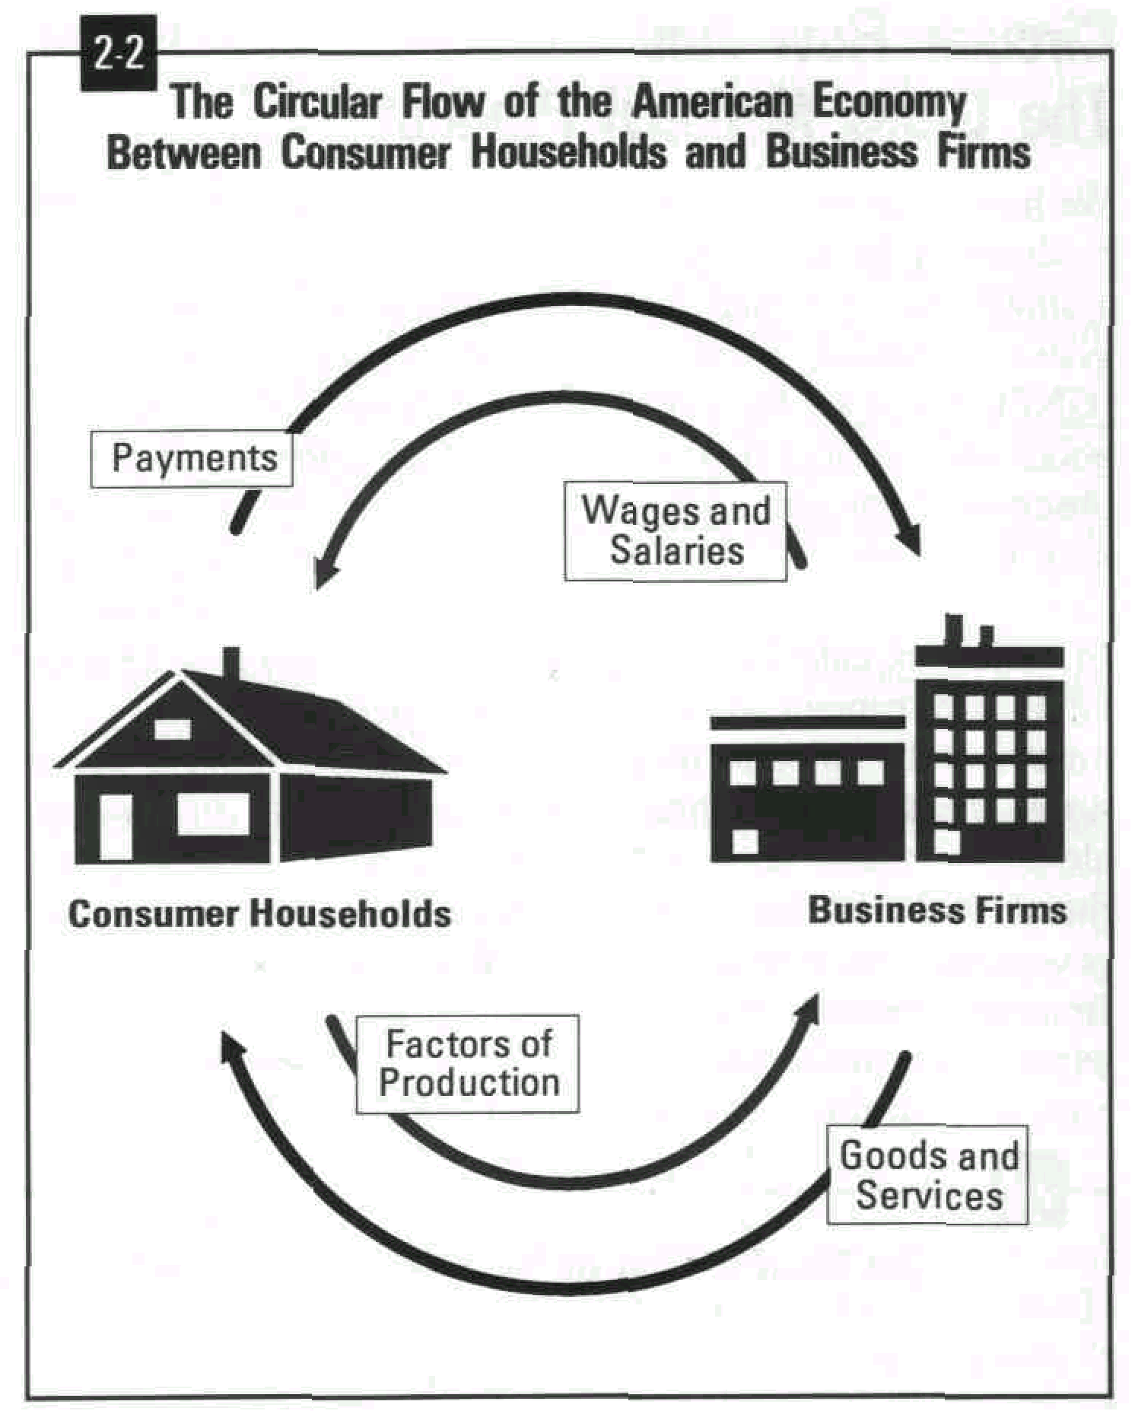
Payments by businesses to households for the use of their factors of production set up a stream of money flowing in the oppo-site direction (Figure 2-2). These provide the funds to pay for consumer purchases of the nation's goods and services.
Now let's flip the second switch, labeled "Government," and see what comes up.

- Replace private enterprise with government management teams by "nationalizing" certain large corporations. (Nationalization refers to a government takeover of what had been a privately owned business enterprise or industry.)
-81-
- Replace nationalized industries with private enterprise by "privatizing" certain government-run industries.
Some of these suggestions are quite controversial. For example, not everyone would agree that reducing business taxes and government regulations is an effective way to increase productivity. Similarly, the nationalization of industry has never been popular in the United States.
It has also been argued that the level of U.S. productivity is just about where one might expect. Those who support this position make the following points:
- Since the U.S. was the only major industrial power to escape damage during World War II, it was able to enjoy an unusually high increase in productivity during the post-war years.
- Other nations are also increasing their production of services as their economies mature.
- "All other things being equal," it is reasonable to assume that all countries are likely to achieve the same level of productivity in the long run.
Most economists would agree, however, that an increase in capital spending (the amount that business invests in new plant and equipment) is a sure way to increase American productivity.

The Importance Of Capital Spending.
The importance of capital spending can be illustrated by comparing productivity increases in Germany and Japan to that of the United States.
Over the 20-year period ending in 1988, West German business invested approximately 20 percent of the nation's GNP in new plant and equipment. During that time, productivity in manufacturing industries increased at an average rate of over 5 percent a year.
In Japan, an average of 33 percent of the nation's GNP was invested in new plant and equipment over the same 20 years. As a result, Japanese manufacturing productivity increased by approximately 11 percent a year.
By contrast, U.S. industry invested approximately 10 percent of its GNP annually in new plant and equipment. As a result, between 1968 and 1988 American productivity increased by an average of only 2 percent a year.

What Can Be Done To

Encourage Capital Spending?
Here are some of the more frequent suggestions for increasing capital spending.
were spending three percent of our GNP on research and development at the beginning of the 1970's. By the 1980's spending had fallen to two percent.
Why is that important? Through research new products and techniques are found that can improve our productivity. Increasing productivity may enable a company to offer wage increases, increase dividends to stockholders, or expand, all without raising prices.
-80-
Growth in Service Industries. Until 1970 there had been a steady shift of people from lower productivity farm jobs to higher productivity jobs in business and industry. That trend slowed in 1970 and has not increased since. Also, there has been increased employment in the so-called service industries - businesses that provide services like health care, appliance repair, and education or training. Productivity in these businesses is hard to measure. Employment in business and personal services rose from 12 percent to 15 percent to 19 percent in the 1950's, 1960's and 1970's respectively. Some service industries, such as health care, have made very slow productivity increases. Some critics argue that we shouldn't even try to measure productivity as output per employee in areas such as health and education, where the quality of the human factor is so important.

What Can Be Done To
Increase American Productivity?
Although economists agree what productivity is and the general trend of American productivity, there is widespread disagreement about how to improve it. Listed below are some of the proposals that have been suggested in recent years.
- Reduce business taxes as a way of stimulating investment in new plant and equipment.
- Reduce the number of government regulations that add to the costs of doing business.
- Find and develop lower-cost sources of energy and reduce dependence on foreign oil.
- Develop ways for management and labor to work as partners rather than adversaries.
- Encourage large corporations to set aside short-run profits to increase productivity in the long run.
- Improve the labor force by providing better education and job training opportunities for all our nation's youth.
- Find ways to reward both management and labor when they improve productivity.
- Reduce waste through more effective quality management.
Adding Government to the Circular Flow. As the telescope shifts its focus, we see the third principal economic sector, government, coming into view alongside households and business firms (Figure 2-3).
-23-
Here, again, we see a stream of services flowing out of house-holds toward government. These are provided by the people (including your teachers, if you are attending a public school) who work for the various agencies of government. The circle is completed by the services provided by government for its citizens.
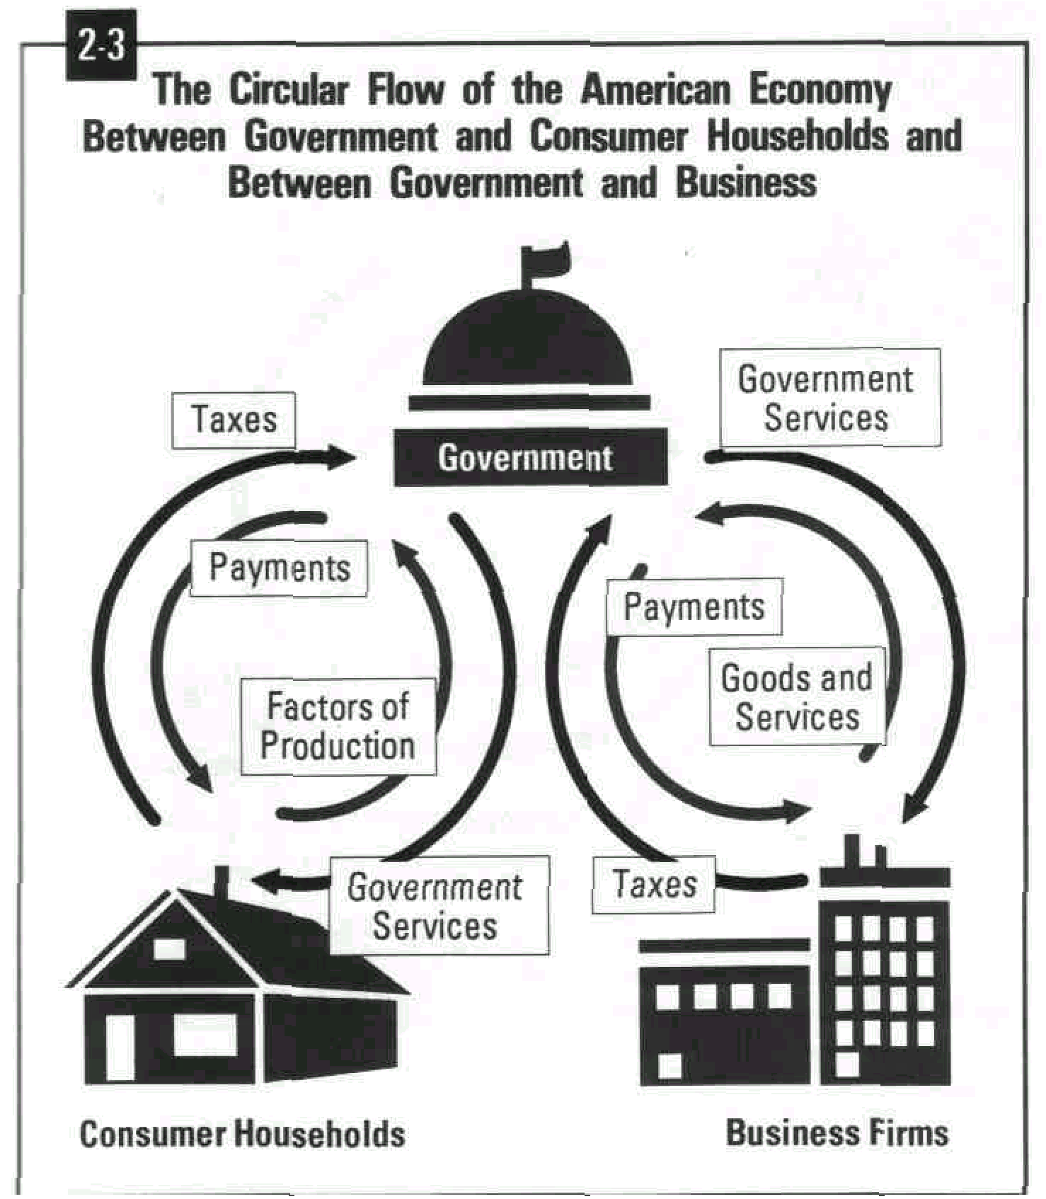
Circling in the opposite direction, from households to govern-ment, are the taxes we all pay. For its part, government sends payments in the form of wages and benefits to its employees and others entitled to receive them.
Similar flows of money and economic resources are circling in opposing directions between government and business firms. In the inner circle we see the movement of goods and services from business to government, and the services provided by government to business. In the outer circle money payments for government's purchases are flowing to business, while tax payments from business firms are streaming back to government.

Circular Flow And The Gross National Product.
We have seen that the total value of the goods and services produced by the economy in a single year is called the gross national product (GNP). These are the same goods and services that we observed from our imaginary telescope.
In order to calculate the GNP, government economists add the amounts that were spent by the three elements of the economy (households, business and government) to purchase the finished products. We can express this mathematically as С + I + G = GNP, where:
С = consumer household spending
I = investment, or business
-24-
G = government purchases of goods and services.
In 1991 the estimated GNP stood at $5,613.6 billion. This was made up of consumer spending which totaled approximately $3,791.2 billion, business investment of about $666.3 billion, and government spending of about $1,145.5 billion.

What Does The Circular Flow

Tell Us About The Economy?
Think of the economy as a kind of pond. But instead of water, the pond consists of all the goods and services that individuals. business and government want and need.
The pond is fed by three streams. These are the streams represented by the flows in our circular flow model. If some-thing happens to increase the size of any of the flows, the level of the pond will rise. If any or all of the flows decrease in volume, the level of the pond will fall.
The level of our economic pond determines how well Americans live. When the pool is rising, things are getting better. Jobs are more plentiful, and there is more of every-thing to go around. When the pool's level is falling, the oppo-site happens. There are fewer jobs, and less of everything.
As you continue your study of economics, you will learn more about the circular flow and its individual components. You will also leam why some times are better than others, and the things that government, industry and labor can do to improve economic conditions at home and abroad.

The American Economic System:

What Are Its Goals?
Our Nation's Economic Goals. There are two sides to the study of economics. One is concerned with describing things as they are. For example, economists can tell us the value of the goods and services the country is producing, the number of people who are employed and unemployed, and the amount of money in circulation.
Economics, however, is also concerned with what ought to be and with designing policies to bring those goals about. The question as to what the goals of American economic policy ought to be is frequently controversial. Each of the following questions, for example, involves economic policy on which people frequently disagree.
- Should government increase its aid to the poor and disadvantaged, or should private agencies assume a larger share of the burden?
- Should tariffs (taxes on imports) be increased in order to protect certain American industries?
In the late 1960's our rate of productivity growth began to slow. According to U.S. Department of Labor statistics, for most of the 1970's the annual growth rate was about 1.5 percent. In early 1982 the estimated growth rate was close to zero, although it has been rising since the middle of 1982. What does it mean?
-79-
One estimate claims that if productivity had continued at k post-war rate, we would all be enjoying an after-tax incom. about 25 percent greater than we currently earn.

Causes Of Declining Productivity.
Changes in the Labor Force. Since the mid-1960's the makeup of the labor force has changed. About then the first young adults from the post-World War II baby boom joined the work force, including an increasing percentage of women. The effect of these young and inexperienced workers on the labor force was a short-term leveling off of productivity in the 1970's.
High Energy Costs. At one time cheap energy accounted for productivity increases. That is no longer true. Since the early 1970's price increases resulted from the policies of the Organization of Petroleum Exporting Countries (OPEC) - a cartel established by oil-producing countries in an attempt to regulate the supply and price of oil. These price increases have had a major impact on productivity, not only in our country, but in all industrialized countries. Money that might have been used for new and more productive machines (capital investment) or other ways to increase productivity has gone into paying for higher energy costs and into finding new or less expensive energy sources.
Declining Investment in Public Capital. Our nation's productivity is directly related to the quantity and quality of available capital (factories, tools, equipment, etc.). While most capital is privately owned, 45 percent is owned by federal, state, and local governments.
The largest portion of public capital is often called the infrastructure, which includes highways; airports; mass transit; and electric, gas, and water facilities. The second-largest portion is buildings, which includes schools, hospitals, and passenger terminals.
Since 1973 investment in public capital has fallen behind the growth in our labor force. This has caused a deterioration of the infrastructure and a drag on productivity. For this reason, many economists argue that government needs to increase spending on public capital. Failure to do so, they add, will cause serious burdens for future generations and lower levels of productivity growth than Americans should otherwise expect.
Reductions in Research and Development. The steady decline in the number of patents issued to U.S. residents since 1971 causes some to say that America is losing its top place in technological development. The facts show that we
other equipment running for longer and longer periods of time. Eventually the point would be reached where the workers would start to get in each other's way, and the machinery would begin to break down. When that happens the point of diminishing returns has been reached, and the cost of producing each additional wagon is greater than the cost of producing the one before.
Economists state the law of diminishing returns this way: As variable inputs (items that would add to variable costs) are applied to the fixed inputs (such as buildings and machinery), output per unit of input will increase. But if the process is continued, a point will be reached (the point of diminishing returns) where the output per unit of input will begin to decrease.
-78-
So far we have discussed how much it cost Mr. Wally to produce his Wallywagons. We have noted that the average cost of the Wallywagons depended on how many were produced. Once he had this information, Mr. Wally could answer a very important question: How many wagons should he produce?
Remember, the plant has a capacity of 10,000 wagons. But when the plant is producing 6,000 wagons annually, average production costs are at the lowest level ($47 per wagon). Should Mr. Wally produce 6,000 wagons or as many as he can?
The number of wagons that Mr. Wally is likely to produce will depend on how many he can sell. Like every wise producer, Mr. Wally knows that the laws of supply and demand will determine how many wagons he should manufacture.
The number of Wallywagons that he can sell will depend in part on their selling price. In a recent market survey (Table 7-2) the Wallywagon staff learned about the effect of selling price on the demand for their product.
7-2
Applying this information to their earlier cost study, the accounting staff was able to draw conclusions about the effect of selling price on profit or loss.
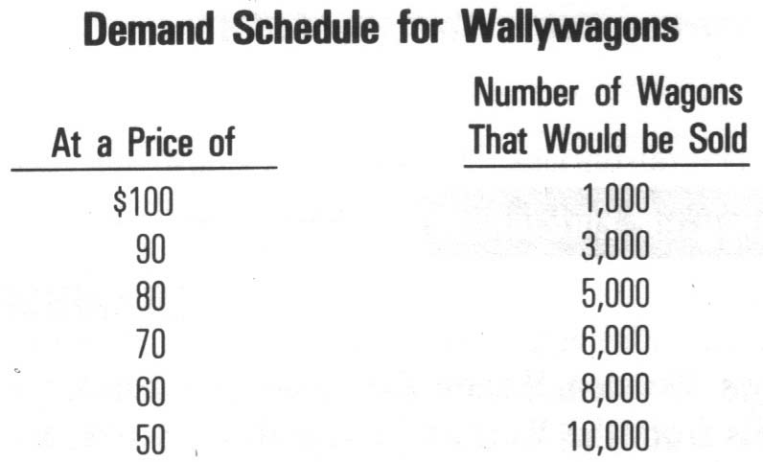

Productivity In The United States.
For about twenty years after World War II, the productivity of American workers increased by about 3.2 percent per yea As a nation we were proud of that accomplishment. We considered ourselves hardworking and industrious, the envy of the world.
- Should efforts be made by government to increase or decrease the power of labor unions?
-25-
How individuals view economic questions depends to a large extent on their personal goals.
Society, too, has goals that it tries to fulfill through its public policies. While some controversy exists, most Americans are likely to agree that a list of the nation's economic goals should include the following. After reading them, you may wish to add a few of your own.
- Full employment. There should be a Job for everyone ready, willing and able to work.
- Economic growth. Increasing the output of goods and services. With more and better goods and services available, everyone's living standard is likely to improve.
- Price stability. There have been times when prices in general increased or decreased at a rapid rate. Such times of inflation and deflation are likely to create hardships for many sectors of the economy. Price stability refers to times during which prices remain constant.
- Economic freedom. We should all have a high degree of freedom to choose how we will earn our livings and how we will spend our money.
- Economic security. For whatever reason, physical handicaps, old age, accidental injury, or the like, there are those among us who are unable to earn their own way. Economic security means that somehow those who are unable to care for themselves fully will be provided for.
- Equity. Equity is the quality of being fair or impartial. As an economic goal, it means that the economic system ought to offer all its citizens equal opportunities to achieve their ambitions.
- Efficiency. Efficiency is a measure of how much we get for what we use. As a national goal, economic efficiency refers to the entire economy's ability to get the most out of its limited resources.
Throughout the rest of this course you may wish to evaluate specific economic decisions and the roles of business firms, government, workers and consumers as they contribute to accomplishing these goals.

Summary:
-26-
In this chapter we described how the pillars of free enterprise-private property, the price system and competition-support American capitalism. We also noted the special role played by profits and other economic incentives in our capitalist system.
We learned about the functions of government in our system and what economists mean when they describe ours as a mixed economy.
The concept of circular flow gave us a pricture of the principal sector of out economy (consumers, business and government).
Finally, we listed the principal goals of our economic system and invited you to suggest additions or deletions.

just want to know my average costs. You know, the cost of each individual wagon."
-77-
"I understand that Mr. Wally," the accountant replied. "Here. Let me show you the results of a cost study we just completed. You'll see what I mean." With that, the accountant whipped out the figures in Table 7-1.
"Hmm," Mr. Wally murmured after looking over the figures. "I think you had better spell out what all this means."
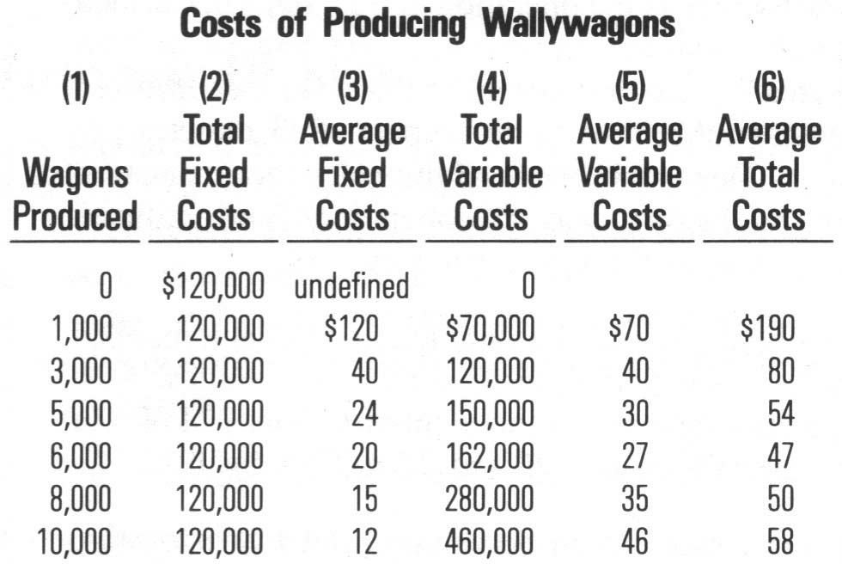
7-1
The following is a summary of the accountant's explanation.
Total production costs are the sum of the fixed costs and the variable costs. If you want to know the cost of a single item you can find it by calculating the average fixed cost and the average variable cost and adding the two together.
The table includes costs for six different levels of production. Production levels are indicated in Column 1, Wagons Produced. Column 2 lists the total fixed costs. You will note that they remain the same at every production level. Total variable costs, listed in Column 4, increase with the output. We will want to take another look at this column in a few moments.
Columns 3 and 5 list the average fixed and variable costs. They are calculated by dividing the total costs in Columns 2 and 4 by the number of wagons produced. Column 1. Average total costs, Column 6, lists the cost of producing a single wagon at each of the six levels of production. They are calculated by adding Columns 3 and 5.
Did you notice that as production increased, it cost less to produce the wagons at first? Then, as output increased still further, so did the cost of each wagon. The reason has to do with another one of those "laws" of economics - the law of diminishing returns.
The Law of Diminishing Returns. Because total fixed costs remain the same at every level of production, average fixed costs must decrease every time the output increases. Why, then, did the average cost of a Wallywagon increase when the firm produced more than 6,000 annually?
The answer is related to average variable costs, which, as you can see in Column 5, declined at first and then began to increase. To increase his output, Mr. Wally would have to hire additional workers and keep his machines and
enjoy the economies of scale - a reduction in costs resulting from large-scale production.
Firms enjoy economies of scale for the following reasons:
-76-
- They can afford to use the full benefits of the division of labor.
- They can buy in quantities that often entitle them to discounts on raw materials.
- They can afford to purchase specialized machinery and equipment to reduce unit costs (costs per item).
- They can afford to invest in research and development programs which enable the company to reduce production costs and produce new and improved products.

Why Production Costs
Change As Output Changes.
We have said that as a firm grows and increases its output, it reaches a point where it costs less to produce each item than it did when the firm was smaller. But why? Why should the cost to produce each item vary as output changes? To answer the question, let's look at two different kinds of cost that go into producing a product.
Total Costs Are Made Up of Fixed Costs and Variable Costs. Wally's Wooden Wagon Company of Wallace, Washington, has been manufacturing its famous "Wallywagon" for over 75 years.
The company operates a small factory with a capacity of 10,000 wagons a year. A firm's capacity is the maximum number of units it can produce. If Wally wanted to produce more than 10,000 wagons, it could do so by adding to its floor space, buying new machines, building a new plant, or making some other improvement in its operations.
Fixed Costs. Wally's accountant has determined that the company's fixed costs come to $120,000 over a year. Fixed, or overhead costs as they are also called, are costs that remain about the same regardless of the amount of business done by the firm. Things such as rent, real estate taxes, a manager's salary and interest on loans are examples of fixed costs.
Variable Costs. In addition to its fixed costs, Wally's Wooden Wagons will also have to meet certain variable costs. Variable costs increase and decrease with the volume of business. Hourly wages, power and raw materials are examples of variable costs. When things are slow, WWW can lay off workers, shut down some of its machines and buy fewer raw materials. When business picks up, those items of expense will increase.
One day, Walter W. Wally, Jr., the firm's owner, asked his accountant what his average costs were likely to be that year.
"It all depends upon how many wagons you are turning out," the accountant replied. "What does the number that we are turning out have to do with it? I
-27-
Chapter 3
SUPPLY. DEMAND AND MARKET PRICE.
_______________________________________________________________
Overview:
As you read this chapter look for answers to the following questions:
- What roles do prices play in a market economy?
- What affects the demand for goods and services in a market economy?
- What affects the supply of a particular good or service?
- How do demand and supply interact to determine prices?
- How do shifts in demand and supply affect prices?
_______________________________________________________________

What? How? Who?
In an earlier chapter we learned that every society must provide answers to the same three questions: What goods and services will be produced? How will those goods and services be produced? Who will receive them? We also learned that different societies and nations have created different economic systems to provide answers to these fundamental questions. Traditional economies look to customs and traditions for their answers. Others, known as command economies, rely upon governments to provide the answers. In free enterprise systems, market prices answer most of the What, How and Who questions.
Because market prices play such an important part in free enterprise systems, those systems are often described as "price-directed market economies." In this chapter you will learn about the forces that determine what prices will be-supply and demand.

Prices In A Market Economy.
Prices perform two important economic functions: They ration scarce resources, and they motivate production.
As a general rule, the more scarce something is, the higher its price will be, and the fewer people will want to buy it. Economists describe this as the rationing effect of prices. In other words, since there is not enough of everything to go around, in a market system goods and services are allocated, or distributed, based on their price. Did you ever attend an auction, or see one conducted on TV? What you saw was the rationing effect of prices in action. The person leading the sale (the "auctioneer") offered individual items for sale to the highest bidder. If there was only one item, it went to the single highest bidder. If there were two items, they went to the two highest bidders, and so on.
Price increases and decreases also send messages to suppliers and potential suppliers of goods and services. As prices rise, the increase serves to attract additional producers. Similarly, price decreases drive producers out of the market. In this way prices encourage producers to increase or decrease their level of output. Economists refer to this as the production-motivating function of prices.
-28-
But what causes prices to rise and fall in a market economy?

Demand.
As the winter draws to a close, many clothing stores find that their inventories (stock of goods held by a business) of ski and other winter clothes are too large. How can you get people to buy ski clothing and other winter items in March and April? Did you say, "Run a sale"? That would be a good suggestion, because people will buy winter clothing in the spring if the price is low enough.
The Law of Demand. Demand is a consumer's willingness and ability to buy a product or service at a particular time and place. If you would love to own a new pair of athletic shoes but can't afford them, economists would describe your feeling as desire, not demand. If, however, you had the money and were ready to spend it on shoes, you would be included in their demand calculations.
The law of demand describes the relationship between prices and the quantity of goods and services that would be purchased at each price. It says that all else being equal, more items will be sold at a lower price than at a higher price.
Suppose that last April two of your friends developed their own special recipe for homemade ice cream, and they decided to sell ice cream cones to students every day after school. They conducted a survey to see if students were interested in the idea. Each student was asked the following question: "Would you spend $.50 to have an ice cream cone for an after-school snack?" This question was repeated using higher and higher prices up to $2 per cone.
The Demand Schedule. The results of the survey were assembled in a demand schedule, a table showing the quantities of a product that would be purchased at various prices at a given time. (Table 3-1)
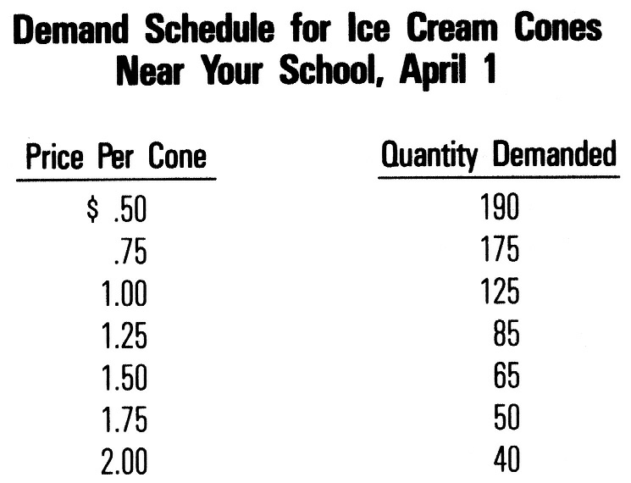

Similarly, management must hire and train the firm's labor force and motivate the workers to do the job. In other words, managers must employ both capital and labor to maximize productivity.
3-1
-75-
How do managers achieve this goal? One way was developed by Henry Ford who introduced a new way to manufacture his Model Т Ford back in 1913. Prior to that time, workers and their tools moved from station to station to complete their tasks in building each automobile. One slow worker slowed everyone else. Ford introduced an assembly line that brought the car to the worker on a conveyor belt. As a result, each worker had to complete his task before the car passed his work station. If a worker could not finish his task in that time, the task was modified or he was retrained or fired.
Another way to increase productivity is to let workers participate in designing and improving the production process. Profit sharing and stock ownership also motivate workers. This is exactly what many companies now do. It has been found that workers with a stake in the firm's welfare work smarter because they get part of the profits when productivity increases.
Business Conditions. There are times when business conditions in general are very good, and others when they are poor. These periodic ups and downs in the economy, known as the business cycle (see Chapter 12), affect productivity. When the economy slows down, sales decline. This leads retail stores to reduce the size of their inventories and postpone adding new lines of merchandise. For similar reasons, when business is poor, wholesalers and manufacturers reduce their inventories and production levels to cut costs.
Although business firms can reduce the size of their inventories and production levels at will, they are often reluctant to lay off workers. Some fear that if business suddenly improved, they might not be able to replace their experienced staff. Others may be concerned about the impact of a layoff on their employees and their families. In other instances union restrictions may prevent employers from laying off workers as quickly as they might other-wise prefer.
Whatever the reason, keeping workers longer than called for by business conditions results in reduced output per worker or, to put it another way, a decline in productivity.
When times are good, the opposite occurs. Employers are able to employ the optimum (best) number of workers, and productivity increases.

Economies Of Scale.
Mass production techniques such as the division of labor, use of complex machinery and the assembly line are most effective in large operations. How large a firm must be before it pays to use such methods varies from case to case. But when a firm reaches that size, economists say that it can begin to
used, power is not limited by human strength but comes from other sources, such as coal, gas, oil, or even atomic power.
New technologies - changes resulting from the use of new machinery and methods - can be used by business to improve productivity. The development of the micro-computer and its application to business problems, for example, has increased the productivity of thousands of businesses.
-74-
To use machinery efficiently, producers must also use division of labor - the practice of breaking down large, complex tasks into a series of small ones so that each worker can become an expert in his or her particular task.
The importance of division of labor has been understood for many years. In one of his more famous passages in his book, The Wealth of Nations, Adam Smith described how pins were produced more efficiently when labor was divided.
"One worker draws out the wire, another straightens it, a third cuts it, a fourth points it, and a fifth prepares it to receive the head. Making the head requires two or three operations, and putting it on the pin is yet another job. Even the placement of the pins in the paper from which they are sold is a job in itself.
I have seen a small factory of this kind in which only 10 men were employed. Small as it was, however, the 10 men could produce as many as 48,000 pins a day. But, if they had worked separately outside of the factory, no one of them could have made as many as 20 pins - perhaps not even one pin."
The pin factory that Adam Smith described also demonstrates the advantages of specialization. Specialization refers to the production of a limited variety of items by a business, region or country. Just as Smith's factory specialized in pins, "Silicon Valley" in California specializes in the production of microchips, and the nation of Singapore specializes in shipbuilding.
By narrowing the focus of their production, business firms and geographic regions become expert at what they do. This enables them to reduce costs. Since lower costs enable everyone to live better, specialization raises living standards. However, specialization also makes us more dependent on one another for the things we need.
As we will see in Chapter 13, specialization has a similar effect upon nations. It improves living standards while making nations more interdependent.
Using Our Resources Effectively. The factors of production can be combined in any number of ways, some more efficient than others. When they are combined efficiently, productivity will be relatively high. When they are combined inefficiently, productivity will be relatively low. Decisions about combining the factors of production rest with management.
In the production process, for example, it is management's responsibility to acquire the necessary capital (in the form of machinery, tools and equipment).
-29-
Why Demand Behaves the Way It Does. The survey results illustrate the law of demand in action. As you can see, the number of ice cream cones that students were ready, willing and able to buy was greater at the lower prices than at the higher prices. Demand behaves the way it does for some of the following reasons.
- More people can afford to buy an item at a lower price than at a higher price.
- At a lower price some people will substitute ice cream cones for other items (such as candy bars or soft drinks), thereby increasing the demand.
- At a higher price some people will substitute other items for ice cream.
- How many ice cream cones can you eat? One, two, more? Some people will eat more than one if the price is low enough. Sooner or later, however, we reach the point where enjoyment decreases with every bite no matter how low the cost. What is true of ice cream applies to most everything. After a certain point is reached, the satisfaction derived from a good or service will begin to diminish. Economists describe this effect as diminishing marginal utility. "Utility" refers to the usefulness of something. Thus "diminishing marginal utility" is the economist's way of describing the point reached when the last item consumed will be less satisfying than the one before.
Diminishing marginal utility helps to explain why lower prices are needed to increase the quantity demanded. Since your desire for a second cone is bound to be less than it was for the first, you are not likely to buy more than one, except at a lower price. At even lower prices you might be willing to buy additional cones and give them away.

Elasticity Of Demand.
The shape and slope of demand curves for different products are often quite different. If, for example, the price of a quart of milk were to triple, from $.80 to $2.40 a quart, people would buy less milk. Similarly, if the price of all cola drinks were to jump from $1 to $3 a quart (an identical percent increase), people would buy less cola. But even though both prices changed by the same percentage, the decrease in milk sales would probably be far less than the decrease in cola sales. This is because people can do without cola more easily than they can do without milk. The quantity of milk purchased is less sensitive to changes in price than is the quantity of cola. Economists would explain this by saying that the demand for cola is more elastic than the demand for milk. Elasticity describes how much a change in price affects the quantity demanded.
How Elasticity is Measured. When the demand for an item is inelastic, a change in price will have a relatively small effect on the quantity demanded. When the demand for an item is elastic, a small change in price will have a relatively large effect on the quantity demanded.
Elasticity can also be measured by the "revenue test." Total revenue is equal to the price times the number of units sold. If, following a price increase, total revenue falls, the demand would be described as elastic. If total revenue were to increase following a price increase, the demand would be inelastic.
-30-
Similarly, if total revenue increased following a price decrease, demand would be elastic. If the price decrease led to a decrease in total revenue, the demand for the item would be described as inelastic.
Super Sally's Supermarket sells 500 quarts of milk and 100 quarts of cola daily. At $.80 a quart she grosses $400 on her milk sales, and at $1 a quart she grosses $100 on her cola. Last week she increased the prices on the milk and cola by 50 percent-milk sold for $1.20 a quart, and cola for $1.50. Following the price increases, milk sales slipped to 350 quarts daily, while soda sales dropped to 35 quarts.
Total revenue from the sale of milk increased (to $420) following the price increase because the demand for milk is inelastic. Total revenue from the sale of cola fell (to $52.50), and for that reason we can say that the demand for cola is elastic.
Why the Demand for Some Groods and Services Is Inelastic.
The demand for some goods and services will be inelastic for one or more of the following reasons:
- They are necessities.
- It is difficult to find substitutes. Cola drinkers can switch to other soft drinks, but there are few substitutes for milk.
- They are relatively inexpensive. People are less apt to change their buying habits when the price of some-thing that is relatively inexpensive is increased or decreased. If, for example, the price of an item were to double from 10 cents to 20 cents, it would have less of an effect on demand than if the price had gone from $250 to $500.
- It is difficult to delay a purchase. When your car is running out of gas, it is not always possible to shop for the best deal.
Changes in Demand. Until now, we have been describing the relationship between an item's price and the quantity of an item people will purchase. Sometimes things happen that change the demand for an item at each and every price. When this occurs, we have an increase or a decrease in demand.
What are some of the factors that would cause the demand for ice cream, or any other product, to increase or decrease at each and every price?
Substitutes. When two goods satisfy similar needs, they are described as substitutes. A change in the price of one item will result in a shift in the demand for a substitute. Black and brown shoes are close substitutes. If the price of black shoes goes up, then people will tend to substitute brown

What Is Productivity?
-73-
Productivity is a measure of how efficiently we work. To measure productivity, economists determine the amount of goods and services produced for every unit of input. Input can be any resource that goes into the production process.
The Cinder Bicycle Company uses two gallons of paint for every 50 bicycles it manufactures. The Ella Bicycle Company can paint 100 bikes with two gallons of paint. When it comes to painting, the Ella Bicycle Company, at 50 bikes per gallon, is twice as productive as the Cinder Bicycle Company at 25 per gallon.
Productivity is usually measured in terms of output per worker per hour.
Cinder Bicycle Company employs 5 workers, each working a 40-hour week. The company produces 200 bicycles a week. Productivity at the Cinder Bicycle plant is 1 bicycle per hour: The 5 employees work a total of 200 hours (5 x 40 = 200). They average one bike per hour because 200 bicycles divided by 200 hours = 1 bicycle per hour.
Ella Bicycle Company employs 10 workers, each working a 40-hour week. The company produces 600 bicycles a week. Worker productivity is 1.5 bicycles per hour: The 10 workers put in a total of 400 hours (10 x 40 = 400), and 600 bicycles divided by 400 hours = 1.5 bicycles per hour.

What Determines Our Productivity?
Our nation's productivity is directly affected by each of the following:
- The quality of our labor force,
- The quality of our machinery and other capital equipment,
- The effectiveness with which we use our resources,
- Business conditions.
The Quality of Our Labor Force. Among the principal ingredients of productivity are the education and training of workers. Well-educated and skilled workers perform their tasks more efficiently than those who are unskilled or poorly educated. It follows that labor productivity can be increased by:
- Improving the quality of education and training programs; and
- Increasing opportunities for people to receive education and training that suits their needs.
Another ingredient in productivity is the enthusiasm workers have for their jobs. Those who like their jobs and feel they gain dignity and respect from the work will produce more than those who lack motivation to do their best.

The Quality of Our Machinery and Capital Equipment. Better machinery is often said to be the best way to increase productivity. When machines are

Chapter 7
PRODUCTION AND MARKETING:
-72-
THE BUSINESS OF BUSINESS.
_______________________________________________________________
Owerview:
As you read this chapter look for answers to the following questions:
- How do changes in production affect living standards?
- How are productivity and production related?
- How can productivity and quality be improved?
- Why do production costs change as output changes?
- What is marketing and what is its place in business?
_______________________________________________________________

Production And The American

Standard Of Living.
Most of us are living better today than our parents and grandparents did when they were our age. And few countries in the world can boast a higher living standard. A nation's standard of living is measured by the amount of goods and services available to its citizens. One way to calculate living standard is to divide total production (the gross national product) by the population (Production / Population = per capita GNP). When production is increasing faster than the population, more goods and services are available per person, and living standards are likely to improve. If the population were to grow at a faster rate than production, average living standards would fall.
Nations wanting to increase production must ask themselves two questions:
- Are our resources fully employed? In other words, are our factories and machines being used to the fullest, and can everyone who is looking for work find a job?
- What can be done to increase production with the resources that we have?
If the answer to the first question is "no," steps to restore full employment will increase production. In Chapters 10 and 12 we will describe some ways our government has tried to maintain full employment.
The second question has to do with productivity. When you study the time and resources that go into production, you're analyzing productivity. When you produce more or better products with the same time and resources, you have achieved a productivity increase.
shoes for black shoes, and the demand curve for brown shoes will shift out at every price. If the price of black shoes goes down, then people will tend to substitute black shoes for brown shoes, and the demand curve for brown shoes will shift in at every price.
-31-
Complementary goods. Goods that are often consumed together, like peanut butter and jelly, are complements. If the price of peanut butter should increase, the quantity of peanut butter consumed will decrease. Since peanut butter and jelly are consumed together, the quantity of jelly demanded at each and every price will also decline, and the demand curve for jelly will shift in.
What are some other factors that might cause the demand for ice cream your friends are selling to increase or decrease at each and every price? How would these changes be reflected in the demand curve? The following is a brief list of factors that might affect the curve:
- Change in the environment. It is a much hotter month than usual.
- Change in the item's usefulness. The Surgeon General of the United States issues a report that states ice cream is good for you and enhances your attractiveness.
- Change in income. Allowances are raised as an economic boom sweeps your community.
- Change in the price of a substitute product. The price of candy decreases.
- Change in the price or availability of complementary products.
- Change in styles, taste, habits, etc.
If any of these events occurred, the demand schedule would change in such a way that the quantity demanded at any particular price would be higher or lower than our original demand schedule indicates. If the demand were to increase, the curve would shift outward. If demand were to decrease, the curve would shift inward.

Supply.
Thus far we have only spoken about the effects of prices on buyers. But it takes two parties to make a sale: buyers and sellers. To the economist, supply refers to the number of items that sellers will offer for sale at different prices at a particular time and place. A supply schedule is a table summarizing this information. Table 3-2 is the supply schedule that was in effect that day in April when your friends conducted their survey. It tells us how many ice cream cones they were willing to sell the students at the prices indicated.
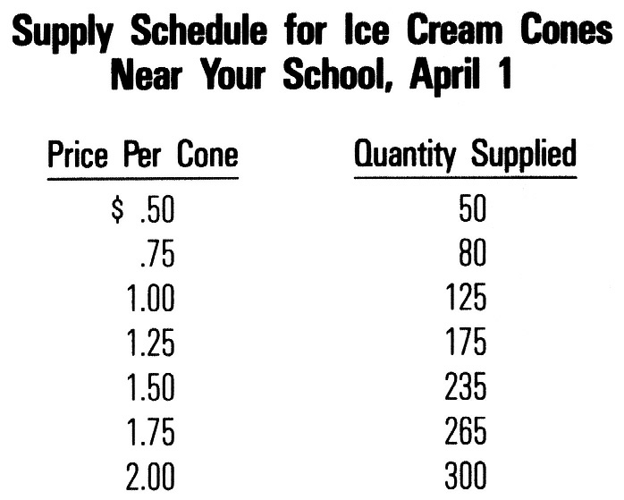
3-2
The Law of Supply. As the supply schedule indicates, more ice cream cones would be offered for sale at higher prices than at lower ones. This is in keeping with the law of supply, which states that sellers will offer more of a product at a higher price and less at a lower price.
-32-
Why does the quantity of a product supplied change if its price rises or falls? The answer is that producers supply things to make a profit. The higher the price, the greater the incentive to produce and sell the product. If ice cream prices around your school are high, your friends may buy a larger ice cream maker so they can produce and sell more ice cream. Additionally, if word gets out that ice cream sells for a relatively high price near your school, other vendors will be tempted to leave their present locations and come to your high school in the belief that they can make more profit.
Our supply schedule is based on holding variables other than price at some fixed or constant level. On this basis we can use the supply schedule to draw the supply curve (Figure 3-3). As in the case of demand, supply curves need not be straight lines. Unlike demand, the typical supply curve slopes upward, from left to right.
Changes in Supply. When supply changes, the entire supply curve shifts either to the right or to the left. This is simply another way of saying that sellers will be offering either more (if supply has increased) or less (if supply has decreased) of an item at every possible price. Any or all of the following changes are likely to affect the quantities supplied.
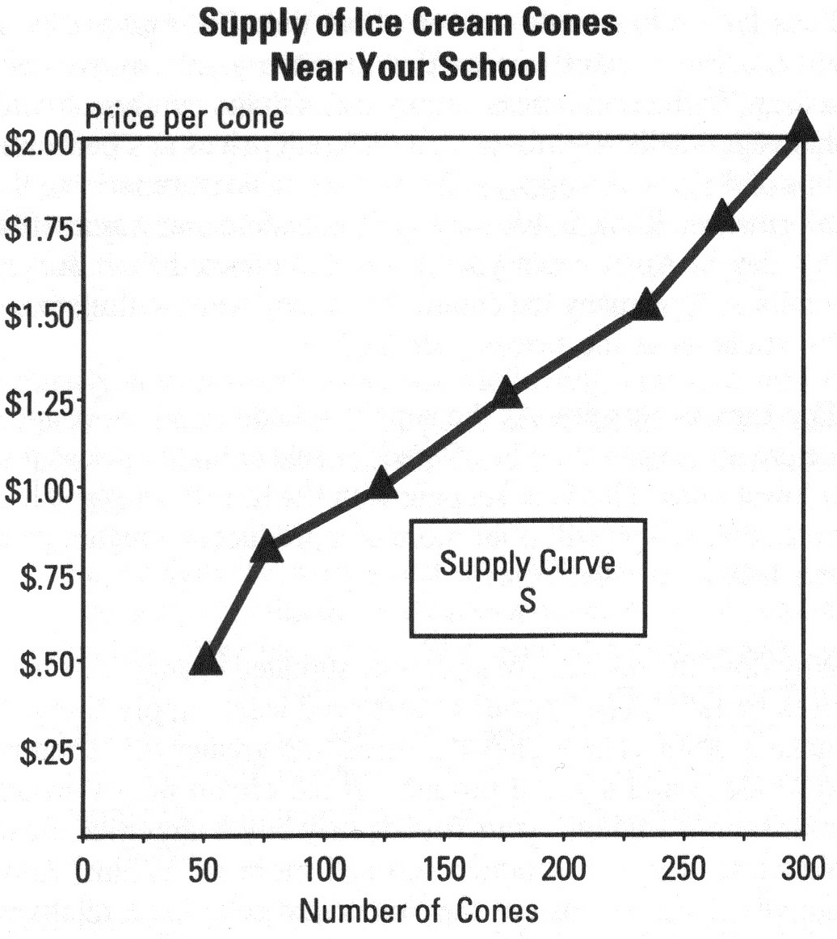
3-3

-71-
Summary:
Business firms can raise money from internal (inside) and external (outside) sources. Most internal funds come out of profits. The principal source of external funds are loans and sales of stock.
Large corporations often raise funds through the sale of stocks and bonds. Bondholders lend money to the corporation and are, therefore, its creditors. Since stocks represent part-ownership of the corporation, stockholders are owners of the firm.
Bondholders receive interest payments during the period of me loan, plus the face value of the bond at maturity. Stockholders receive a share of the profits in the form of dividends when and if the board of directors declares them. When stockholders sell their shares, they will receive whatever the market value is at the time of sale.
Publicly held stocks and bonds are traded in stock exchanges or over-the-counter markets. Those who trade corporate securities do so for reasons of investment or speculation.
The government agency responsible for overseeing the operations of the securities markets is the Securities and Exchange Commission (SEC). The SEC subscribes to the principle of caveat emptor ("let the buyer beware").
Investors and others interested in the financial condition of a firm can learn much from its income statement and balance sheet.
Business Accounting:
Balance Sheet And Income Statement.
-70-
Two of the most important pieces of information contained in every prospectus and annual report are the balance sheet and the income statement. The balance sheet summarizes a corporation's assets, what it owns; its liabilities, what it owes; and its net worth, the difference between the two sums at a given time. The income statement summarizes a firm's revenues, costs, and the difference between the two (the profit or loss) over a period of time.
The Balance Sheet. For every business the things that it owns are assets, and those that it owes are liabilities. The difference between the two, which is how much more the business owns than it owes, is its net worth. In other words:
assets - liabilities = net worth
or assets = liabilities + net worth
Balance sheets are usually presented in the second form, with the assets on one side and the liabilities and net worth on the other.
About the balance sheet:
- Accounts receivable are the sums owed to Snugasabug by its customers.
- Inventories are rugs and other merchandise the company has for sale.
- Accounts payable are the sums that Snugasabug owes its suppliers.
- Notes payable are short-term loans owed by the corporation.
- A mortgage is a long-term loan, usually used to finance a building.
- Net worth is the difference between assets and liabilities. Snugasabug had net assets of $528,000 and liabilities of $235,000, leaving them with a net worth of $293,000. Theoretically, a corporation's net worth represents the amount that would be available for distribution to its stockholders if it were to liquidate (go out of business and convert everything it owned to cash).
The Income Statement. The income statement, or profit-and-loss statement as it is also called, shows how much a business has made or lost over a period of time (usually a year). In the income statement we can see that Snugasabug sold $570,841 worth of its rugs. It cost the company some $409,450 to produce and sell these goods, leaving them with a profit of $161,391. Out of this, some $32,200 was paid in taxes, leaving Snugasabug with a net profit after taxes of $129,191.
Snugasabug's board of directors voted to distribute $50,000 in dividends to its stockholders, while the balance of the funds, $79,191, was retained by the company and added to its surplus.
- Changes in the cost of production. If it costs sellers less to produce their products, they will be able to offer more of them for sale. An increase in production costs will have the opposite effect-supply will decrease.
-33-
- Other profit opportunities. Most producers can make more than one product. If the price of a product they have not been producing (but could if they chose to) increases, many will shift their output to that product. For example, as personal computers increased in popularity, a need developed for computer stands. As a result, many furniture manufacturers began to produce desks and carts specifically designed for the computer market.
- Future expectations. If producers expect prices tc increase in the future, they may increase their production now to be in position to profit later. Similarly, il prices are expected to decline in the future, producers may reduce production, and supply will fall.

Equilibrium.
Supply and demand schedules tell us how many items buyers would purchase and how many items sellers would offer at different prices. By themselves they do not tell us at what price goods or services would actually change hands. When the two forces are brought together, however, something quite significant takes place. The interaction of supply and demand will result in the establishment of an equilibrium or market price. The market price is the one at which goods or services will actually be exchanged for money.
To illustrate, let's bring our demand and supply schedules for ice cream together as follows:
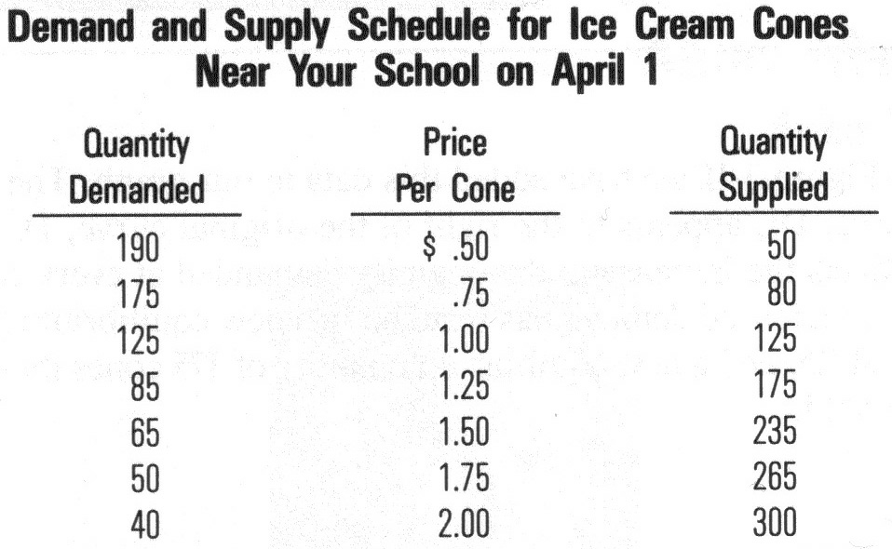

3-4

The price at which supply exactly equals demand is known as the market price, or the point of equilibrium. In the table above, the market price would be $1.00 because at that price the quantity of ice cream cones demanded and the quantity supplied are exactly equal.
Perfect Competition Conditions. The market price is the only price that can exist for any length of time under perfect competition conditions. Perfect competition exists when the following conditions prevail:
- Buyers and sellers have full knowledge of the prices quoted in the market.
-34-
- There are many buyers and sellers so that no individual or group can control prices.
- The products are identical with one another. Therefore, it would not make sense for buyers to pay more than the market price, nor for sellers to accept less.
- Buyers and sellers are free to enter or leave the market at will.
But why is the equilibrium price the only one that can exist for any length of time?
Excess Quantity Demanded. Suppose ice cream cones sold for $ 0.50 on April 1. As you can see from the Demand and Supply Schedule (Table 3-4), at that price 190 cones would be bought. Vendors, however, would supply only 50 cones at that price. Then, as the students gobbled up the 50 available cones, other students hungry for ice cream would clamor for more. There would be an excess demand for ice cream.
Meanwhile, the remaining vendors, learning of the unfilled demand for ice cream, would offer their cones at prices higher than 50 cents. These, too, would be sold, until such time as the quantity demanded at a particular price exactly equaled the quantity supplied.
It follows that an excess quantity demanded will lead to price increases, and that the increases will continue until demand and supply are equal.
Excess Quantity Supplied. By contrast, let us suppose that as ice cream sales began on April 1, the price was $1.50 per cone. In those circumstances (see Table 3-4) 65 cones would be bought. Vendors, however, were prepared to sell 235 cones at that price. That is, there was an excess quantity of 170 cones supplied.
With all that ice cream in their freezers, vendors who could afford to do so would begin to offer cones at lower prices. As ice cream prices came down, more and more would be sold. Here, again, the process would continue until the quantity supplied exactly equaled the quantity demanded.
We may conclude that an excess quantity supplied will result in price decreases until a new equilibrium is reached.
Equilibrium Price and Quantity. In both instances, prices increased or decreased as long as it took buyers and sellers to "clear the market," that is, to arrive at a price where the supply and the demand for ice cream were exactly equal.
If, however, ice cream cone sales had begun at $1, prices would not have changed at all. This is because $1 was the equilibrium price where the quantity demanded exactly equaled the quantity supplied.
As long as supply and demand remain unchanged, the equilibrium or market price will remain constant.

Bears ''sell short.'' Expecting the price of a stock to fall, bears borrow the stock from their brokers and sell it at today's price. If and when the price does fall, they repurchase the stock at the lower price, return it to their brokers, and pocket the difference. The broker is paid a fee for these services.
-69-
Grace Blue feels that the stock of the DEF Corporation is due for a fall. DEF is currently selling for $13 a share. She instructs her broker to sell 300 shares of DEF short. Blue's broker lends her 300 shares of DEF which she then sells for $3,900. Two weeks later DEF is selling for $10 a share. Grace tells her broker to close out her transaction. The broker buys back the 300 shares of DEF (that had been loaned to Blue) for $3,000. As a result of her short sale, Grace Blue has earned a profit of $900, less brokerage fees. If, instead of falling, the price of DEF had risen, Grace would have lost money.
Buying and Selling Corporate Bonds. When a corporation sells its bonds to the public, it makes two important promises: to pay the bondholder a fixed rate of interest for a specific number of years and to repay the face value of the bond when it comes due.The sale of bonds is handled in the same way as the sale of stocks. Corporations in need of capital sell their bonds to underwriters for a fixed sum. The underwriter then sells the issue to the public. Once the bonds are in the hands of the public, future sales are handled by the stock exchanges and the over-the-counter market. As with stocks, the market value of bonds depends upon supply-and-demand conditions at the time. Individuals thinking of investing in corporate bonds should compare the safety and yield of those securities with those offered by thrift institutions. There is some risk of default (failure to pay interest or principal) on the bonds of even the strongest corporations, whereas most thrift institution accounts are insured by the government.
Mutual Funds.
How do you know which stocks to buy? Once you've bought them, don't you have to keep an eye on them? How would you know when to sell your stocks?
In fact, no one really knows the best stocks to buy or exactly when to sell them. For that reason many people invest in mutual funds. Mutual funds are corporations that sell stock and use the proceeds to invest or speculate in the securities markets. Because they work with large sums of money, they can afford to buy many securities, to spread the risk of investment. Risk is spread because a loss by one or two securities would be offset by gains in the others. The mutual funds can also afford to hire professional managers to look after their investments.
exchange, or the over-the-counter market. Naturally, the proceeds from those transactions go to the sellers, not the individual corporations.
A securities exchange is a market where brokers meet to buy and sell stocks and bonds for their customers. Securities exchanges list the securities of approximately 3,000 of the nation's largest publicly owned corporations.
-68-
Largest of the securities exchanges are the New York Stock Exchange and the American Stock Exchange. The New York Stock Exchange handles about 80 percent of all securities transactions, whereas the American Stock Exchange handles 10 percent. The remaining transactions are made at a number of regional exchanges located around the nation.
If you wanted to buy or sell corporate securities, you would probably call upon the services of a local brokerage firm. An account executive (salesperson licensed to sell securities) would take your order and transmit it to the company's representative on the floor of the exchange. The exchange works like an auction. Brokers representing buyers and sellers bid against one another for the best possible price.
The over-the-counter market consists of brokerage firms around the nation that buy securities of the smaller, "unlisted" firms and sell them to the public. There are more than 40,000 corporations whose securities are traded "over the counter."
Investing and Speculating. Those who buy stocks to share in the profits and growth of a corporation over a long period of time are described as "investors." Those who buy or sell stocks as a way to earn a fast profit are known as "speculators."
Investing in Corporate Stocks. Investors share in a corporation's profits by receiving periodic dividends. In addition, if the corporation prospers over the years, its stock will increase in value. Investors will be able to sell the stock for more than they paid for it, thereby earning a capital gain or "profit" from the sale.
Speculating in Corporate Stocks. Stock market speculators fall into two groups. One group, commonly known as bulls, hopes to profit by correctly predicting an increase in the value of a stock. The other group, bears, hopes to profit by correctly predicting a decrease in the value of a stock.
Bulls are said to "buy long." That is, they buy stocks intending to hold them until they can be sold at a higher price.
Stanley Green thought that the stock of the ABC Corporation, then selling at $5 a share, would soon increase in value. He instructed his broker to buy 200 shares. Two weeks later, the price of ABC stood at $6. Stanley told his broker to sell his shares. Before subtracting the commissions that he had to pay Ms broker, Stanley made a profit of $200. Had the price gone down to $3.50 a share at the time he sold, Stanley Green would have lost $300.
The Effects Of Changes In
-35-
Demand And Supply On Market Price.
The Effects of Shifts in Demand. Returning to your school's ice cream market, let us suppose that early in April the plumbing system of a neighboring high school broke down. The accident resulted in the transfer of a large number of students to your school.
The addition of all those students, many of whom enjoy ice cream, has increased demand. This is reflected in Demand Schedule 3-5.
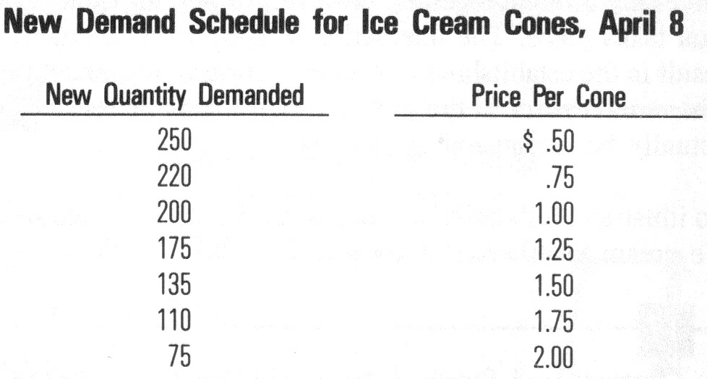

3-5

In Figure 3-6 we have added this data to our graph. The new curve, Dl, appears to the right of the original curve, D. This reflects the increase in the quantity demanded at every price. The increased demand has resulted in a new equilibrium price of $1.25, and a new equilibrium quantity of 175 cones that will be sold.
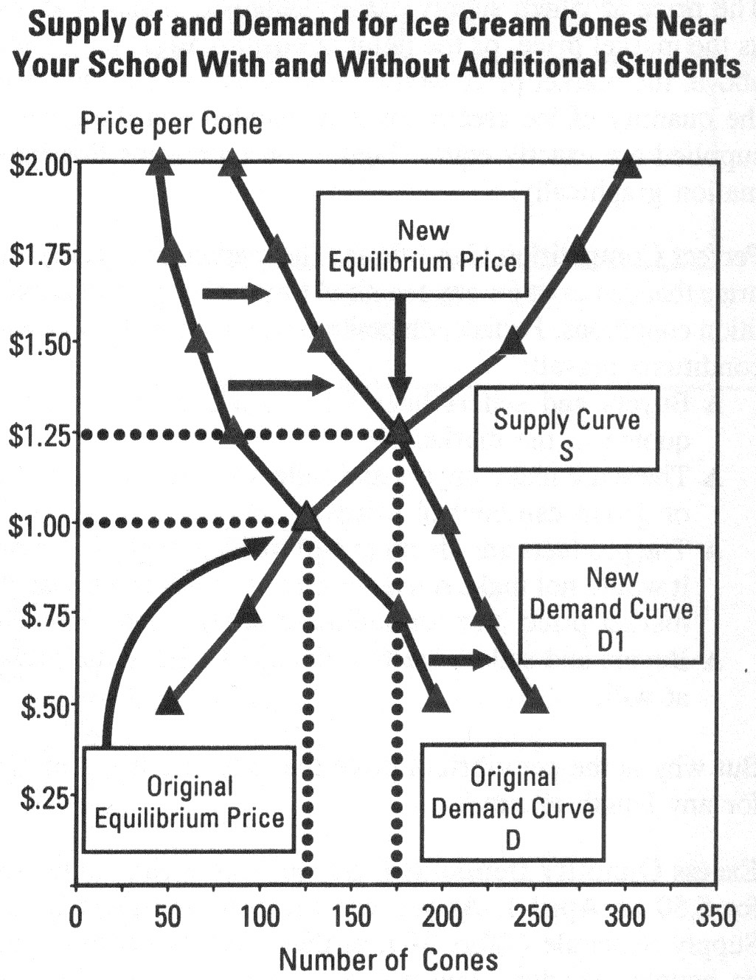
If, on the other hand, demand had decreased, the demand curve would have shifted to the left (or downward). In that event, the curves would have intersected at a lower equilibrium price and quantity.
3-6
The Effect of Shifts in Supply. Now, rather than a plumbing accident, let's assume instead that the circus came to town in April. Ice cream vendors, thinking that business outside the Big Top would be spectacular, moved to that side of town. With fewer vendors remaining to serve your school, the quantity supplied at every price would be far less than before.
-36-

Alfred Marshall (1842-1924)
Price Theory Pioneer.
The topics discussed in this chapter had their origins in the writings of the great English economist Alfred Marshall. His textbook, Principles of Economics (1890), and the doctrines that it discussed, became the standard for the teaching of that subject until well into the 1940's. Marshall spent most of his adult life as a professor of economics at Cambridge University. His most famous pupil, John Maynard Keynes, described Marshall as "the greatest economist of the 19th century." Interestingly, Keynes went on to become the most influential economist of the 20th century.
Marshall is best known for the order that he made out of the theories of the earlier "classical economists" like Adam Smith, David Ricardo and John Stuart Mill. ("Classical" is the name given by modern economists to the theories of those whose views were most widely held during the 75 years following the publication of The Wealth of Nations.) Despite the passage of 100 years since the publication of his Principles, his analysis of market forces is still relied upon to explain economic events.
In Marshall's world, economic events could be explained in terms of the equilibrium market price resulting from the interaction of supply and demand. One of Marshall's lasting contributions was differentiating between supply and demand in the short run and the long run. Comparing the two forces to the blades of a scissors, he argued that neither could function without the other. But, just as (depending on how the scissors is held) one blade can be more active than the other, so supply and demand vary in importance in the long and short run. In the short run, the quantity of available goods is more or less fixed (because crops have been planted, production schedules set, etc.). Therefore it is the demand for those items that will be most influential in determining their price. In the long run, he went on, the opposite is true. Both farmers and businesses can add to or reduce their production facilities as the needs dictate. In that way the supply side of the market becomes most influential in determining price.

How The Price System Answers
The What, How And Who Questions.
We have said that the American economic system is described as a price directed market system. That is, when supply and demand operate freely, the
The XYZ Corporation has issued 100,000 shares of common stock, and 50,000 shares of $5 preferred (stock that pays $5 in dividends). Last year the board of directors declared dividends of $500,000. $250,000 of this sum went to the preferred stockholders (because 50,000 * $5 = $250,000). The rest of the money went to the common stockholders who received $2.50 for every share of stock they held (because $250,000/100,000 = $2.50).
-67-
This year, the company lost money (it earned no profits). Therefore, the board of directors had to decide whether to:
- pay the preferred stockholders a dividend out of savings and skip paying a dividend to the common stockholders,
- pay their regular dividend to the preferred stockholders and another dividend to the common stockholders out of savings, or
- skip paying dividends to both the preferred and common stockholders.
The board chose the third alternative.
Buying and selling corporate securities (stocks and bonds) takes place in the "stock market" or "bond market." The attention given to the stock market by radio, TV and the newspapers is evidence of the widespread interest in stock ownership. So, too, is the fact that over 47 million people now own stock in America's corporations.
Protecting the Investing Public. The Securities and Exchange Commission (SEC), an agency of the federal government, is responsible for protecting investors in the sale of securities. It operates on the principle of caveat emptor, a Latin phrase meaning "let the buyer beware." In applying this principle, the SEC requires corporations to provide the public with essential information about their operations and finances. Having done that, they let investors determine the risks for themselves.
Much of the information required by the SEC is contained in a prospectus. Similar to the annual report distributed to stockholders, a prospectus is prepared for any new issue of securities.

How Stocks and Bonds Are First Offered to the Public. Corporations sell stocks and bonds (securities) as a way of raising capital. Once a corporation decides to sell its securities, it will look for a firm willing to buy the entire issue and sell it to the public. The securities firm underwrites-advances the agreed-upon price for the stocks or bonds to the corpora-tion-and then sells the securities to the public. It makes a profit if sales go well but must absorb any losses if sales are weak. Often a securities firm will join with other similar firms to spread its risk by forming a syndicate to sell the bonds.
Securities Exchanges and the Over-the-Counter Market. We have seen that the proceeds from the sale of new stocks and bonds go to the companies issuing them. Thereafter, sales are handled either through a securities
equipment, launching a major research effort are the kinds of projects that require long-term financing.
Why would anyone lend money to a business for a year or more? The reason is that revenues from these kinds of projects (like a new factory) continue to flow for a long period of time. This makes it possible for borrowers to repay their loans as promised.
-66-
The most common sources of long-term financing are retained earnings, long-term loans, and the sale of stock.
We have seen that corporations can do one of two things with their profits: distribute them to their shareholders in the form of dividends, or "plow them back" into the business. Undistributed profits, or retained earnings, are often used to finance major projects.
Long-term loans are repaid over more than one year. The most common form of long-term loan is the mortgage, a loan secured by real estate (land or buildings). If the borrower fails to make payments on the mortgage, the lender may take the property. Families who own a home or apartment probably have a mortgage on the property.
Many large corporations raise long-term capital through the sale of their bonds. Corporate bonds are a kind of IOU sold to the general public, usually in denominations of $1,000. The corporation promises to repay the face value of the certificate at a specified time. In addition, the bondholder receives interest at periodic intervals (usually twice a year). Because the money paid for a bond is really a loan, bondholders are considered creditors of a corporation. This means the corporation is legally obligated to pay the bondholders the interest and principal of the loans as they come due.

Buying And Selling Stocks And Bonds.
Stocks as a Source of Funds. Large corporations often raise funds through the sale of their stocks to the general public.
Unlike bondholders who are creditors of the corporation, stockholders are its owners. This entitles them to a voice in the selection of the board of directors and a share of the potential profits, when and if the directors elect to distribute them.
Common and Preferred Stock. All corporations issue common stock; some, however, also issue preferred stock.
Common stock entitles the holder to a voice in the management of a corporation and a share of the profits. Unlike common stockholders, preferred stockholders usually do not have voting rights. However, preferred stock receives preferential treatment over common stock in two ways: 1) it receives a specified dividend before any dividends are paid on the common stock, and 2) it receives a share of the assets ahead of the common stockholders if the corporation should be liquidated.
prices they generate provide the answers to the What, How, and Who questions.
-37-
What Goods and Services will be Produced. The demand for a particular item can be described in a demand schedule or demand curve. Since producers are in business to earn profits, their decision to produce specific goods and services will depend on their ability to earn a profit at a price consumers are willing to pay and a quantity they will buy. If consumer demand increases, more items will be provided at the higher price. If demand decreases, the opposite will occur.
Of course, producers are free to ignore consumer demand and produce as much or as little as they choose. But those who produce goods to sell at prices consumers are not willing to pay will suffer financial loss. So, too, will those who produce less than they might have sold at the market price.
How Goods and Services will be Produced. The market system answers the How question by rewarding those who reduce their production costs and punishing those who do not. We can illustrate this with the following hypothetical example.
Annamayshunn, Inc. manufactures joy sticks that whole-sale for $15 through computer stores and other outlets. (Joy sticks are devices used to control the animated characters in many computer games.) At the present time, the company relies exclusively upon hand assembly, and its production costs average $12 per unit.
Recently, Annamayshunn, Inc. learned of a machine that could be used to reduce the amount of hand labor required to assemble joy sticks. The company's engineers have calculated that the machine would enable the firm to lower production costs for that item by 25 percent, to $9 per unit. Based on their recommendations, Anna Shunn, the firm's president, has decided to alter production methods by investing in one of the new machines.
Can you see why Annamayshunn, Inc. might decide to revise the way it manufactures joy sticks? With production costs at $9, the company stands to double its profits from $3 to $6 per unit at the current market price.
Even if the market price should fall, Annamayshunn's reduced costs will enable it to sell its goods at a lower price. For example, let's suppose that other joy stick manufacturers also reduce their costs and as a result the supply of joy sticks is increased. As you know, an increase in supply reduces market price and, sure enough, the market price of joy sticks falls from $15 to $12 per unit.
Fortunately Annamayshunn, Inc., can operate profitably at the new market price. Had it not changed its production methods, it might have had to go out of the joy stick business.

Who will Receive the Goods and Services that are Produced?
-38-
Market prices provide a means of rationing the economy's scarce resources. That is, they help determine who will receive goods and services and who will not.
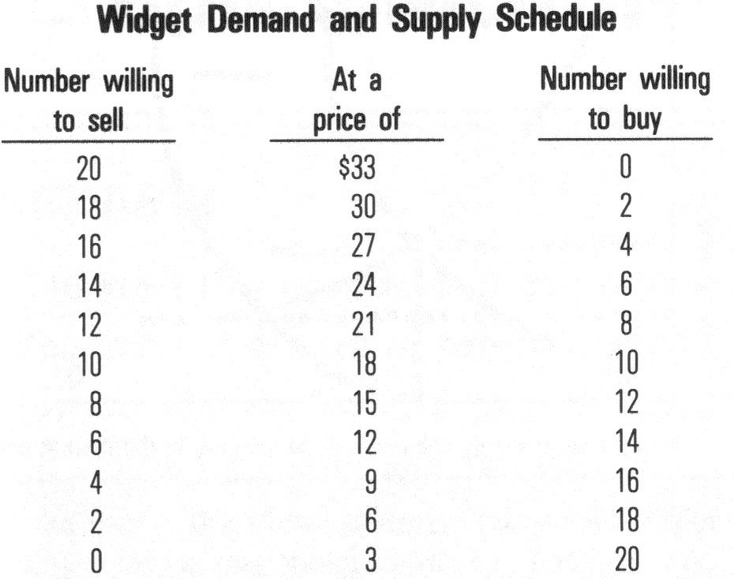
Table 3-7 contains a demand and supply schedule for the ever-popular hypothetical product. Widgets. In this market there are 20 buyers and 20 sellers, each of whom would like to either buy or sell 1 Widget. As you can see from the table, equilibrium falls at a market price of $18, where 10 Widgets will be sold.
3-7
But there were 20 buyers and 20 sellers in this market, and as we can see, only 10 Widgets were actually sold. That means that ten buyers went home empty handed, and ten sellers still owned Widgets. How did the market make its rationing decisions? That is, which buyers got to own a Widget, and from whom did they buy?
The buyers who purchased Widgets were the ten who were willing to pay $18 or more for the item. Those who did not buy a Widget were the ten who set $15 or less as their limit.
Those who sold Widgets were the ten willing to take $18 or less for the item. Those unable to sell their Widgets were the ten who set $21 or more as their lowest selling price.
In this way the market decided who would get to buy and sell Widgets and who would not.
In some countries, prices are set by the government. When that happens, the economy can be faced with either shortages or surpluses. Shortages occur when the established price is below the market equilibrium. At those points, there are more buyers than there are sellers, and some other way needs to be found to allocate resources. It may be on a first-come, first-served basis, in which case there are likely to be long lines at the stores. Or the government may decide to institute some kind of rationing (as was done by our government during World War П). Government rationing often leads to the creation of black markets and other efforts to circumvent (get around) the system.
- borrow,
-65-
- sell shares of stock (if it is a corporation) or seek additional capital from the owners (if it is a partnership or proprietorship),
- reduce spending.

When Business Borrows.
Business loans are generally classified as either short-term or long-term loans. For short-term loans, the principal (the amount borrowed) must be repaid within one year. Long-term loans mature (come due) in more than a year. Creditors, people who make loans, expect to receive interest, payments for the use of their money, and the return of the principal (the amount loaned) at the end of a specific period of time. Interest is expressed as a percentage of the principal.
Short-term Financing. Short-term loans are used to finance the everyday costs of doing business, such as payrolls, raw materials and merchandise. Long-term loans are more likely to be used to purchase equipment, buildings and other high-cost items. The most common types of short-term financing are trade credit, loans from financial institutions, and loans from investors.
Trade credit is like a department store charge account. Customers charge purchases to their accounts for payment at a later date. In the case of trade credit, the customers are businesses whose suppliers allow them to charge purchases for payment at a later date.
Loans from financial institutions, such as banks and finance companies, are another source of short-term credit.
Finally, some of the nation's largest businesses can look to loans from investors to meet their short-term financial needs. If, for example. General Motors needed $10 million to finance a payroll, it could raise the money by selling commercial paper - a kind of IOU issued by a corporation, promising to repay a sum of money at a specified rate of interest. Investors wishing to earn interest on their surplus funds can buy these IOU's from brokers specializing in such investments.
Federal law requires that all loans be expressed in terms of the annual percentage rate or APR. The APR of loans that are discounted is always higher than the rate quoted. This is true because the amount the borrower received is less than the amount actually loaned.
In the example below, Snugasabug had the use of only $9,600 for the three months of the loan, not the $10,000. Thus the $400 in interest was paid on a loan of $9,600. $400 is 4.17 percent of $9,600 and since the money was loaned for only 3 months (or one quarter of a year), the annual percentage rate (APR) was 16.68 percent.
Long-term Financing. Long-term financing is money that will be used for a year or more. Building a factory, purchasing
Chapter 6
FINANCING A BUSINESS.
-64-
_______________________________________________________________
Overview:
As you read this chapter look for answers to the following questions:
- How do businesses obtain funds?
- How is the cost of borrowing calculated?
- How and why do some people trade in stocks and bonds?
- How does the government regulate the sale of securities?
- How do you read a balance sheet and income statement?
_______________________________________________________________

The Sources Of Business Funds.
As you read this chapter you will learn how business obtains the funds it needs to finance its operations. You will also see how some large corporations raise capital through the sale of stocks and bonds to the public. Finally, you will learn why some people follow the day-to-day activities of the securities markets and how they invest in stocks and bonds.
In many ways, money is to business what water is to plants. Plants need water to begin life, to survive and to grow. Similarly, firms need money to begin operations, to meet their day-to-day expenses and to expand. Most of the money used by business comes from the sale of its products and services. Since these funds come from within the firm they are described as internal funds. The rest must come from outside, or external, sources.
Internal Funds. As a firm sells its products or services, it receives money which it uses to meet its expenses. One of these expenses, depreciation, represents the cost of replacing assets (like tools, machinery, and buildings) that wear out. Typically, businesses use internal funds to cover the cost of depreciation.
The funds that remain after paying expenses are a firm's profits or earnings. Although the owners or stockholders could take it all for themselves, in most instances some portion of the profits will be retained by the business. Since its "retained earnings," along with the sum it set aside for depreciation came from within the firm, they are known as internal funds. About 60 to 70 percent of a business firm's financing comes from its internal sources.
External Funds. Sales do not remain constant from one season, or month or week to the next. There are times when more money comes in to a business than is needed to pay its bills. Similarly, at other times there is not enough money coming in to cover operating costs. When this happens, there are only four things that the firm can do:
- dip into savings,
-39-
Summary:
Market economies are directed by prices. As the price of an item rises, sellers are encouraged to increase production, and consumers are discouraged from purchasing the item. When the price falls, the opposite is true. In this way prices send out "signals" to buyers and sellers, keeping the economy responsive to the forces of supply and demand.
In a free market economy, prices are determined by the interaction of the forces of supply and demand. Perfectly competitive markets are those in which many buyers and sellers, with full knowledge of market conditions, buy and sell products that are identical to one another.
Demand is the quantity of goods or services that buyers would purchase at all possible prices. Demand varies inversely with price. That is, at a higher price fewer items would be bought than at a lower one. The degree to which price changes affect demand will depend upon the elasticity of demand for a particular item.
Supply, which is the quantity of goods or services that sellers would offer for sale at all possible prices at a particular time and place, varies directly with price. In other words, at a higher price, more goods and services will be offered for sale than at a lower one, and vice versa.
The price at which goods and services actually change hands is known as the equilibrium, or market price. It is the point at which the quantity demanded exactly equals the quantity supplied. Market price can be represented graphically as the point of intersection of the supply and demand curves.
Shifts in demand or supply will affect market price. When everything else is held constant, an increase in demand will result in an increase in market price, and vice versa. Similarly, an increase in supply will result in a decrease in price, and vice versa.

Chapter 4
THE CONSUMER IN OUR ECONOMY
-40-
_______________________________________________________________
Overview:
As you read this chapter look for answers to the following questions:
- What are the sources of personal wealth?
- How do personal budgets, the services of banks and other savings institutions, insurance plans, and consumer credit help you get more for your money?
- What are some techniques advertisers use to sell their products?
- How can you make wiser consumer choices?
- How do the government and private agencies protect consumers?
_______________________________________________________________

Your Role As A Consumer.
Take a few minutes to add up the money you spend in a month on tapes and CD's, hamburgers and fries, new shoes and clothes, movies, and all the other "necessities." You might be surprised to discover just how much money you and your friends spend and contribute to the economy. Across the nation, teenagers spend almost $17 billion each year!
Advertising agencies work overtime and spend millions of dollars to create ads that will attract your attention. Many American businesses, like "rock" radio stations, clothing manufacturers, motion picture studios, cosmetic companies and many others, work very hard to meet your needs and wants. The money you, your friends and other teenagers spend makes you important consumers and an important force in the economy. In 1990, consumers purchased over 60 percent of the GNP-more than $3 trillion in goods and services!

The Sources Of Income.
Before you can consume anything, however, you must do two things. First you must earn the income to buy the things you want. Then you must decide how the money will be spent. There are two ways to earn income: from your work and from the use of your wealth.
Income From Work. Most of the income you are likely to earn will come from work. In return for working, you will receive a wage or salary. (The term "wage" typically refers to the earnings of workers paid by the hour or unit of production. "Salary" refers to earnings paid on a weekly or monthly basis.) How much you earn will depend on your job, your abilities, your performance, and a number of other factors. Table 4-1 summarizes the average earnings of a variety of jobs.
Consumer relations departments operate to see that statements made by their companies are accurate. Misrepresentations about a product or service are illegal.
-63-
Consumer Safety. Another name for consumer safety is "product responsibility." Every company has the responsibility to safeguard consumers from undue hazards in the storage and use of the product. A company even has a responsibility to warn against the misuse of a product. During production, consumer safety is best protected by keeping products free from defects.
Companies must warn against potential hazards in using their products. The producer has the obligation to understand and follow regulations of the Food and Drug Administration and other federal offices. Food, chemicals, electrical products and children's toys require especially careful protection planning.

Summary:
Entrepreneurs who organize business firms are motivated by the possibility of earning profits. They should also know, however, that those who enter into such activities risk the possibility of losing money if the business is not successful.
Those thinking of starting a business should keep informed about the kinds of opportunities that exist, the personal qualities needed for success, and the kinds of training available to prepare for the world of business.
Business firms are organized as sole proprietorships, partnerships or corporations. Although proprietorships outnumber the combined total of the other two by about three - to one, corporations are by far the most important. Reasons for the importance of the corporation have to do with its key advantages of unlimited life and limited liability. These enable it to raise sums of money well beyond the limits of the partnership and the proprietorship.
The organization of large corporations enables them to be run efficiently despite having thousands of owners. Through the use of such devices as boards of directors, proxy voting and annual reports to the stockholders, management is separated from ownership.
Businesses also have a responsibility to protect the public against hazardous merchandise and misinformation about their products.
corporation, a summary of its achievements, plans for the future, and other information the directors wish to share with the stockholders.
-62-
Business Responsibility To The Consumer.
Like other groups in the economy, the majority of Americans in business are honest, hardworking men and women who want to treat the consumer fairly. They are concerned about earning a profit for their efforts, but they are also concerned about their responsibilities to the consumer. Concern about responsibility, which we call business ethics, goes hand in hand with concern for profits. Sooner or later consumers will identify irresponsible firms and refuse to trade with them. By contrast, those firms that acquire a reputation for high quality, informative and convenient packaging, labeling and consumer safety are likely to profit.
Product Quality. A consumer has the right to expect uniform product quality. That means that if a company makes and sells a product today and again tomorrow, the two products should have the same quality. The consumer also has the right to expect that the product will do what it is advertised to do for a reasonable length of time. Once a standard of quality has been established by a company, it should not be lowered, and it is the responsibility of workers and managers in that company to see that it is not. Firms that pay close attention to quality and develop procedures for monitoring the quality of their products and services are likely to be more successful than those who don't.
Product Packaging. Packaging can perform a number of valuable functions. It can protect the product from the time that it is manufactured until it is sold. It can inform the consumer about the quantity and quality of the contents.
And it can enhance the appearance of the product to increase sales.
Critics of modem American marketing techniques say that fancy packaging only serves to raise the price of a product. It's what's inside that counts, they say, not the fancy wrappings.
Defenders say that quite the opposite is true: packaging that serves to increase sales reduces prices. Greater sales, they argue, reduce the costs of production for each individual item, enabling manufacturers to sell their products for less. (See Chapter 7 for a discussion of the effect of large-scale production on unit costs.)
Product Labeling. Some products carry informational labels or testing labels from trusted, private, consumer testing organizations. Good Housekeeping magazine tests products that appear in its advertising. It guarantees consumer satisfaction if the product is used properly. Underwriters Laboratories tests electrical products for potential fire hazards and shocks. To many shoppers the UL label is a statement of potential consumer satisfaction.
-41-
Median Monthly Earnings by Job Category 1990
4-1
Job Category | Median Monthly Wage
Lawyer | $4,533
Airline Pilot | 3,891
Electrical Engineer | 3,675
Pharmacist | 3,441
Architect | 3,012
Economist | 2,986
Computer Programmer | 2,834
Accountant | 2,743
Registered Nurse | 2,635
Telephone Repairer | 2,609
Firefighter | 2,578
Police Officer | 2,422
Mail Carrier | 2,401
Electrician | 2,271
Teacher, Elementary | 2,249
Plumber | 2,201
Real Estate Agent | 2,197
Librarian | 2,119
Auto Sales | 2,011
Clergy | 1,876
Truck Driver | 1,863
Carpenter | 1,785
Photographer | 1,777
Auto Mechanic | 1,703
Computer Operator | 1,621
Bill Collector | 1,586
Farm Manager | 1,573
Bus Driver | 1,534
Secretary | 1,486
Telephone Operator | 1,382
Butcher | 1,361
Machine Operator | 1,356
Laborer | 1,339
Cab Driver | 1,335
Dental Assistant | 1,300
File Clerk | 1,226
Janitor | 1,213
Retail Sales | 1,118
Car Washer | 1,079
Hair Dresser | 1,070
Hotel Clerk | 1,014
Cashier | 932
Waiter/Waitress | 901
Housekeeper | 823
Food Counter Worker | 797
Over the next few years you and your classmates will be leaving school to enter the job market. When you do, the career you choose and the job you get will be the result of the thought and effort you put into preparing for it.
-42-
Income From Wealth. Wealth can be expressed as the value of the things you own. Adding the value of all your possessions, bank accounts, savings, and the like will give you the total amount of your wealth.
Used in certain ways, wealth can earn income. If you owned a motorcycle, you might be able to let others use it for a fee. In that instance economists would say that you used your wealth to earn "rent." Wealth, in the form of money that is loaned to others or deposited in a savings account, will earn interest. As you can see, interest and rent are two forms of income that can be earned by wealth. As you read on, you will learn about other types of income (such as dividends and capital gains) that can be generated from your wealth.

Getting The Most For Our Money.
The number and value of things we are able to buy depends upon the size of our income and how wisely we spend it. The Blues and the Greens, both families of five, have similar incomes. The Blues spend their money as fast as it comes in on the things they want at the moment.
The Greens, on the other hand, plan their expenditures and savings very carefully. When the time comes to make a major purchase, they compare products and prices before making their decision.
It is not difficult to see why the Greens get more value for their money than the Blues. They give thought to their expenditures and plan for the future. The family that spends its money wisely will get more out of its income than the one that spends it carelessly. In the pages that follow, you will learn some ways to get more for your money.
A Budget Can Help. As consumers, all of us are limited by what we can spend. We know that money used to buy one thing reduces our ability to buy something else. Most of the time, we are able to keep track of our expenditures (the money spent) so we are able to meet our immediate needs. But every now and then we find ourselves unable to buy something we wanted simply because the money was not available.
To help keep track of income and expenditures, many people use personal budgets. A budget is a financial plan that summarizes income and expenditures over a period of time. When a budget has expenses that exactly equal income, it is said to be balanced. When proposed expenses are greater than expected income, the budget is said to have a deficit. Budgets in which income exceeds expenditures will have a surplus.
Although there are as many ways to prepare a budget as there are people who use them, the process usually involves three steps: setting financial goals, estimating income, and planning expenditures.
many franchisors require that the products must be purchased from the parent company at whatever price it chooses.
-61-

How Large Corporations Are Organized.
Charter and Bylaws. A corporate charter is a kind of license issued by the state in which a corporation has been created. If your student company is a production company, it too will be issued a charter entitling it to function in a way similar to a corporation. Corporations also are required to have a set of rules by which they operate. These rules are called bylaws.
Stockholders. The stockholders are the owners of a corporation. If any member of your family owns shares of stock in, for example, the Exxon Corporation, that would make him or her a part-owner of the nation's largest oil company. The number of stockholders in the publicly held corporations (those whose stock is sold to the public) can run into the hundreds of thousands. Some corporations (such as AT&T) are owned by more than a million stockholders.
With thousands of owners scattered from one end of the country to the other, large corporations need some way to operate efficiently. The election by the stockholders of a board of directors accomplishes this goal.
Board of Directors. Corporate boards of directors are elected - usually annually - by the corporation's stockholders. In many ways they are like school boards in local communities. Just as your local school board selects superintendents and principals to operate its schools, so boards of directors choose the president and other officers to run their companies. Decisions about funds for development, how to expand, and what dividends, if any, are to be distributed to the stockholders remain with the directors.
The effect of this arrangement is to separate ownership from management. Those who run the company are responsible to the directors who hired them, rather than to the stockholders directly.
Although ownership and management are separated in a large, open corporation, stockholders can participate indirectly by exercising their right to vote. Stockholders do elect boards of directors and vote on other matters affecting policy.
Corporate elections are unique. Unlike political elections in which everyone can cast a single ballot, stockholders are entitled to one vote for every share they own. For example, if you owned fifty shares of Exxon stock, you could cast fifty votes at every corporate election.
Voting usually takes place at a corporation's annual meeting. Stockholders unable to attend can submit a written authorization, known as a proxy, voting their shares as they instruct.
Once a year the directors of a publicly held corporation issue an annual report. The annual report contains information about the financial status of the
with regular corporations, the services of a lawyer are usually needed to organize an S corporation.
Not-for-profit corporations. As the name suggests, not-for-profit corporations do not seek to earn a profit. Rather, they serve particular educational, social, charitable or religious purposes. Since they earn no profits, they are not subject to income taxes. Some not-for-profit corporations you may be familiar with are the American Red Cross, the March of Dimes and, of course, Junior Achievement.
-60-
Government-owned corporations. Federal, state, and local governments own and operate corporations. In most instances these were created to provide services that private enterprise was unable or unwilling to offer. The U.S. Postal Service, the Federal Deposit Insurance Corporation, Amtrak, some metropolitan rapid transit services, and other publicly owned utilities are examples of government-owned corporations.
Cooperatives. Cooperatives (or co-ops) are associations of individuals or companies organized to perform business functions for their members. You may already be familiar with:
- Housing co-ops, multiple dwelling units owned by their tenants.
- Consumer co-ops, retail businesses owned by members who share in the profits and/or purchase goods and services at lower cost.
- Producer co-ops, companies that manufacture and market products on behalf of their members. One of the largest of these is Ocean Spray Cranberries, Inc. This cooperative of nearly a thousand cranberry and citrus growers from around the country has annual sales of nearly $500 million.
Franchises. A franchise is a license to operate an individually owned business as if it were part of a large chain. Many clothing, real estate, fast food and motel chains are franchise operations.
Franchises provide advantages. Since the money to pay for a new franchise is provided by the franchisee (those who purchase the franchise), franchisors (corporations that sell their franchises to others) are able to expand their operations at little cost to themselves. Franchisors also benefit because franchisees are owners rather than employees of the business. This provides the kind of incentive that can lead to increased sales and profits.
Those who buy franchises also benefit. Many firms provide training programs, financial assistance and other kinds of help in operating and managing the business. Franchisees also benefit from the sales and name recognition generated by the company's advertising campaigns and reputation.
Franchises do have some disadvantages. Franchisors retain a great deal of control over their franchisees. They may dictate how the business is to be operated, the building decorated, even types of uniforms and signs. In addition,
-43-
Setting Financial Goals. Although much of your income is likely to be used for day-to-day needs, you will also want to plan for the more costly items you would like to buy in the future. Further education, a car, a business of your own cost far more than you could hope to pay out of current income. For that reason, you will want to have a savings plan to help you achieve such goals in the not-too-distant future.
Estimating Income. The next step in preparing a personal budget is to draw up a list of all your sources of income. These would include things such as part-time jobs, allowances, gifts, and interest on savings.
Planning Expenditures. Finally, you will want to list all the things you are likely to buy or to pay for over the period. This will enable you to mink through your wants and eliminate those things you can do without for now.
Suppose, for example, that your proposed expenditures total $100 more than your anticipated income. You would then have to decide which items could be removed to bring the totals into balance. As you complete the process, you will be dealing with opportunity costs. The items dropped from your budget will represent the opportunity cost of those you keep.
This will also be the time to include savings to meet your financial goals, as we discussed above.

The Importance Of Savings.
Have you noticed how many different kinds of institutions would like to hold your savings? Hardly a day passes without hearing a commercial or reading an ad describing the advantages of one kind of savings program over another.
While you may have found these claims and counter-claims to be confusing, don't let them discourage you from starting some kind of savings program. Saving is, after all, one of the most important things that people do with their incomes. Through systematic savings, you can acquire the things you want and be better able to deal with the unexpected, such as the loss of a job, illness, and the uncertainties of old age.
What should you look for when you shop for a place to save?
Just as it pays to shop before making an important purchase, it also pays to shop for a place to save. Safety, Rate of Return and Liquidity are factors to consider.
Safety. One of the first things to think about when you save money is safety. You could hide your savings in your mattress or a desk drawer, but if you're smart you won't. They are the first places your little brother or sister is likely to look. Banks and savings institutions, on the other hand, protect your money against fire, theft and other disasters.
In addition, most of them offer government-sponsored insurance that guarantees the safety of your savings up to $100,000. No one has ever lost a penny from one of these insured accounts. Nor has anyone with savings in U.S. Government bonds ever lost money. Other securities, however, are less safe. The stocks and bonds of private corporations often decline in value and, on occasion, have even become worthless.
Rate of Return. One of the main reasons people save their money is to earn interest, the income from allowing someone else to use one's capital. The amount that they earn is known as the rate of return. The rate of return is expressed as a percentage of the amount on deposit for a period of a year. A deposit of $100 in an account paying 5 percent, for example, would earn a total of $5 in interest over a year. The $5 is the return; the rate of return is 5 percent ($5 divided by $100).
-44-
Most accounts offer compound interest. This is interest computed on the principal and on the interest that was previously paid.
The rate of return offered by banks and savings institutions will vary with economic conditions and the length of time they hold your money. It is also important to distinguish between rate of return and yield, the actual amount of interest earned. Yield depends on the rate of return and the frequency of compounding.
The First National Bank pays 8 percent, compounded quarterly (four times a year), on their savings accounts.
The Second National Bank pays 8 percent also, but that interest is compounded annually (once a year). A $1,000 deposit in the First National would be worth $1,082.43 at the end of the year, whereas the same would be worth $1,080. The rate of interest was the same at both banks, but due to more frequent compounding at First National, its yield was $2.43 greater.
Liquidity. Liquidity is a measure of the ease with which you can convert your savings to cash. The easier it is to withdraw your funds, the greater the liquidity.
Liquidity has a price, however. The hockey player who used the Automatic Teller machine probably had to pay a service charge, and in general, the easier it is to withdraw your money from a bank or savings and loan, the lower the interest rate the institution will pay. Table 4-2 lists common savings opportynities.

With all these advantages you might wonder why there are so many more unincorporated businesses than incorporated ones. The answer has to do with the disadvantages of the corporation:
-59-
- It is difficult and expensive to organize a corporation. The process of obtaining a charter usually requires the services of a lawyer. Most small firms prefer to avoid these expenses by forming proprietorships and partnerships.
- Corporations are subject to special taxes. The federal government, along with many state and local governments, taxes corporate income in addition to the taxes paid by shareholders on their dividends. (Dividends are the portion of a corporation's profits that are distributed to the stockholders.)
- Corporations whose stock shares are sold to the public give up their right to privacy. The law requires that these large, open (or public) corporations disclose information about their finances and operations to anyone interested in reading about them. The purpose of this legislation is to give people information about companies in which they might invest. But information that helps investors may also be of value to the competition. For that reason, some corporations have chosen to remain closed (or private) corporations rather than disclose information they would prefer to keep secret.

Special Types Of Business Organizations.
Not all business organizations fall neatly into the categories tfaat we have described. Other types of business organization arc described below.
The S corporation - the corporation for small business. A small business can enjoy many of the advantages of the corporation without being subject to corporate taxes if it organizes as an S corporation. S corporations take their name from a Congressional addition to the income tax law known as Sub-chapter S.
Unlike a regular corporation whose profits are subject to the corporation income tax and the individual income tax, S corporations are taxed like a partnership. That is, profits or losses re allocated to the stockholders in proportion to the number shares they hold and are reported on their regular tax return.
Hurley Burleigh owns 25 percent of the shares of Blye's Barley, Inc.. Blye's is an S corporation. Last year, the firm earned a profit of $60,000. Since his share of the profits came to $15,000, Burleigh reported that amount as income on his tax return.
In order to qualify for S corporation status, a firm must not have more than 35 stockholders and cannot own more than 80 percent of another corporation. As
Such was the case with Harold Nodough, Gloria Poor and Jack Rich who owned the Trio Dress Shoppe as a partnership. Under the terms of their partnership agreement, Nodough and Poor were each entitled to 40 percent of the profits, while the remaining 20 percent went to Rich. Last month the firm collapsed. After selling off everything it owned, the company still owed its creditors $10,000. Since Nodough and Poor had no assets of their own, the creditors recovered the total amount from Jack Rich's personal bank account.
Partnership agreements, however, can be designed to limit the liability of each partner so that investors like poor Mr. Rich can be protected.
-58-
- Anytime a partner dies or withdraws from the business, the partnership is legally terminated. If the business is to continue, a new partnership agreement must be drawn up.
- The amount of capital that a partnership can raise is limited. Exactly what that limit is will depend on the earnings of the business, the wealth of the partners, and their ability to borrow.
- Partners may disagree, causing management conflicts that could threaten the firm's existence.
Corporation. A corporation is a business organization created under a government charter. Ownership of a corporation is represented by shares of stock, and for that reason corporate owners are known as stockholders.
One feature of the corporation is that the courts treat it as a legal "person." It can, for example, sue or be sued and enter into contracts, and it must pay taxes.
Although corporations are outnumbered by about four to one by sole proprietorships, they dominate American business. Corporations are so important because of the advantages they offer over sole proprietorships and partnerships:
- Limited liability. Unlike the owners of proprietorships and partnerships, who can be held personally liable for the debts of their firms, the most that corporate shareholders can lose (i.e., their liability) is limited to whatever they paid for their shares of stock. Limited liability is thought to be so important that corporations in most English-speaking countries outside of the United States add the abbreviation "Ltd." (for Limited) to their company name.
- Ease of transfer. Stockholders can enter or leave a corporation at will simply by buying or selling shares of stock in that corporation.
- Unlimited life. When the corporate stockholders die, their shares of stock are passed on to their heirs. Mean-while, the corporation is free to conduct business as usual.
- Tax advantages. In certain instances individuals can reduce their tax liability by incorporating.
-45-
Where People Put Their Savings.
4-2
Most of the nation's personal savings are held by the commercial banks, different types of savings institutions, and credit unions. The deposits held by these institutions are insured by agencies of the federal government. Savings institutions offer one or more of the following kinds of accounts:
- Passbook and statement savings accounts. The safety of your money and high liquidity are the most important advantages of these accounts. Minimum balance requirements are usually quite low, and your savings can be withdrawn at any time. The disadvantage of passbook and statement savings accounts, however, is that they pay relatively low interest rates.
- NOW (Negotiable Order of Withdrawal) accounts. NOW accounts pay interest and allow the depositor to write checks. NOW accounts generally offer a slightly lower rate of return than savings accounts.
- Money-market accounts. These insured accounts allow you to write a limited number of checks while participating in the "money market" where banks and other businesses buy and sell short-term credit instruments, notes and other kinds of lOU's that come due in a year or less. The most common of these notes are United States Government Treasury bills. The United States government "sells" Treasury bills as a way of borrowing money. Treasury bills are safe investments, and money deposited in these accounts earns a return which is based on returns from U.S. Treasury bills. The rate of return for money market accounts is usually higher than for passbook savings accounts.
- Certificates of deposit. Certificates of deposit, or CD's, pay the highest rates of interest offered by banks and savings institutions. They require the money to be left on deposit for a specified period of time that can run from a few weeks to five or more years. The money can be withdrawn early, if necessary, but not without a penalty
- Credit-union accounts. Credit unions, associations of people with some-thing in common, often serve people who have the same employer, work in the same industry, or belong to a particular church, labor union, or club. Credit unions offer insured savings plans similar to those offered by other savings institutions. In most instances, however, the rate of return offered by credit unions is higher than that of the other institutions.
- U.S. savings bonds. U.S. savings bonds can be purchased at most savings institutions. Guaranteed by the United States government, they are one of the safest investments one can make Since 1986 the bonds pay no less than 6 percent interest when held for five years. After five years bonds earn a variable rate adjusted every six months.
- Money-market funds. Money-market funds use the resources of their investors to buy money-market certificates. Money-market funds generally pay a higher rate of return than savings and NOW accounts. Unlike other accounts at savings institutions, money-market fund accounts are not insured nor do they provide check-writing privileges.

Planning For Emergencies.
-46-
Theft is only one of the daily risks of life. Accident, sickness, and natural disasters are some of the others. Just as we do our best to avoid the physical consequences of these perils, we can also protect ourselves from their financial cost. We do this by sharing the risk of that loss with others through insurance.
Insurance Enables People To Share Risk. Suppose you lived in a neighborhood in which 100 people owned bicycles. The average cost of the bikes was $200. Past experience in your community has shown that one bike will be stolen per year. Of course, no one knows which bike that will be, but we do know that it will be one of them.
Let's also suppose that each of the 100 bicycle owners put $2 into a common fund. Now when a bicycle is stolen the person who suffered the loss could be reimbursed (up to a total of S200) out of the common fund.
Insurance is based on the principles contained in this example. Insurance companies calculate the odds of a particular event occurring (like fire, accident, earthquake, etc.). This enables them to compute how much will be needed to pay those who have losses. Then they add an amount to cover administrative expenses and profits. The total cost is then divided among the group in accordance with how much risk each faces. This charge, or premium, is the price paid to be covered by the insurance.
Almost everyone in the United States is covered by some form of insurance. Most common of these are life, health, property, and liability insurance. Let's take a look at each of them.
Life Insurance. The principal purpose of life insurance is to provide money for a family when a wage earner dies. There are three types of life insurance policies: term, whole life, and endowment.
- Term insurance. Term insurance provides coverage for a specific period of time (usually 1, 5, 10, or 20 years), and is the least costly form of life insurance. When the term ends, so does the insurance (though it can be renewed at a higher rate).
- Whole life. Whole life enables those insured to pay the same premium throughout their lifetime. It also accumulates a "cash value." This is a kind of savings account that increases in value over the years.
- Endowment insurance. Endowment insurance protects the insured for a specific number of years. At the end of that time the full amount is paid to the policyholder. If the policyholder should die some time before the maturity date, the amount is paid to the beneficiary.
Health Insurance. The purpose of health insurance is to provide protection from the financial problems arising out of accident or illness. Health insurance provides two kinds of benefits. One covers the medical, hospital and surgical costs arising from illness and accident. The other protects against the loss of income resulting from illness or injury.
Forms Of Business Organization.
-57-
Steven Jobs and many other entrepreneurs have organized their companies as corporations. A corporation is one kind of business organization. Other kinds of business organizations are sole proprietorships and partnerships.
Sole Proprietorship. A sole proprietorship is a business owned by one person. As indicated in Table 5-1 sole proprietor-ships are the most numerous kind of business organization, but most are very small. The reason for their popularity is that they are the easiest and least costly to organize.
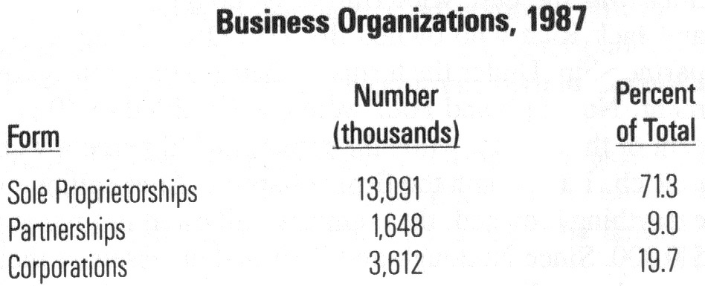
5-1
There are other advantages. Sole proprietors own all the profits of their enterprises, and they are their "own bosses," free to make whatever changes they please. They have minimal legal restrictions and do not have to pay the special taxes placed on corporations. Sole proprietors also have the opportunity to achieve success and recognition through their individual efforts.
There are also disadvantages. A very serious one is the unlimited liability that each proprietor faces. All debts and all problems associated with the business belong to the owner. If a business fails, the owner must personally assume the debts. This could mean the loss of personal property such as automobiles, homes and savings. A second disadvantage of the sole proprietorship is that it has limited capital. The money that a proprietor can raise is limited by the amount of his or her savings and ability to borrow. Also, when the owner dies, the business dies. Other disadvantages may include lack of opportunities for employees, limitations of size and growth and lack of management resources.
Partnership. A partnership is a business organization that is owned by two or more persons. Partnerships offer certain advantages over sole proprietorships:
- Partners bring additional funds to a proprietorship.
- Partners can bring fresh ideas and talents to business organizations.
- Like the sole proprietorship, partnerships are relatively easy to form and are not subject to special taxation.
Partnerships have the following disadvantages:
- In many cases, each of the partners is subject to unlimited liability. Partners are individually responsible for all the debts of the business. In other words, if the business were to fail, its creditors (those to whom money is owed) would have the right to recover their money from any, or all, of the partners.
of Small Business, the share of small business output has been declining since the early 1960's. Large companies, in part due to their efficiency, have taken over markets that previously belonged to small businesses. Nevertheless, estimates for 1976 showed that small businesses, defined by the Internal Revenue Service as businesses having fewer than 500 employees, accounted for 39 percent of all the goods and services produced in America.
According to the report, small businesses face many other problems. Bad economic times affect small business more than they do big business. In addition, small business profits tend to fall faster, and small businesses are more likely to fail. According to the President's report, "The larger larger the firms, the better the chance it has of surviving." The report also said, "A, firm with 21-50 employees has a 54 percent chance of surviving four years. A firm of under 20 employees has a 37 percent chance of surviving four years."
-56-
What are the problems that face small business now? In January, 1985 the National Federation of Independent Business reported that the four top problems facing small business at that time were taxes, slow sales, the high cost of borrowing money and competition from other businesses. On the bright side, the innovativeness of entrepreneurs in small businesses is likely to enable a small business to react quickly and successfully to changing times. The report points out that 80 percent of new jobs are provided by businesses with 100 or fewer employees. Small businesses produce twice as many innovations per employee as larger firms. Those innovations are the source of new jobs and new opportunities for entrepreneurs.
Where is entrepreneurship most likely to be welcomed? The answer is in small business. In fact, the word "entrepreneur" is frequently used to define a small business owner, since the owners of small businesses usually carry out many of the functions of those businesses themselves. In a large business the tasks of organizing and operating are done by many hired managers.
Large and small businesses organize in different ways to meet their objectives. As you will learn later in the chapter, risk is diffused in corporations. Corporate leaders may risk their own jobs when they make major decisions that affect the future of the corporation negatively. But even if they lose their jobs, they have not lost personal investments. Because of the tremendous resources available to big business, a major failure in a large corporation is less likely to close that business than a similar disaster in a small business. But risk and size are only part of the story.
The very nature of the corporate business environment may not be suited to the independent personality and motivation of the typical entrepreneur. Large corporations may want bright and creative entrepreneurial talent to develop new or improved products or services. But large corporations, with their established procedures and layers of management authority, arc seen as limiting innovation and the freedom the independent entrepreneur seeks.
- Medical insurance. Basic coverage pays all or part of physicians fees, hospital services and surgical procedures up to a certain limit. Major medical protects against the extraordinary expense of long-term illness and serious injuries. It starts where basic medical coverage leaves off. Catastrophic insurance pays the costs resulting from the most serious kinds of illness and accidents. The limits of catastrophic insurance coverage can reach into the hundreds of thousands of dollars.
-47-
- Disability income insurance. Serious illness or injury can also cause loss of income. Disability insurance is designed to offset this risk by providing cash payments while the wage earner is recovering.
Individual vs. Group Insurance. When the time comes, you will buy your health or life insurance as an individual or through a group. Group policies are offered by employers, professional associations, unions, and other organizations to their employees or members.
Many firms pay all or part of the group insurance premium for their employees. But whoever pays, group insurance is usually less costly than individual insurance. Another advantage of group insurance is that group members do not have to take a medical examination in order to qualify for coverage. This is a plus because people in poor health may be denied insurance, or required to pay a higher premium, after taking the physical examination required by an insurance company.
Health Maintenance Organizations (HMO's). One form of group insurance provides its members with complete medical coverage. This is the health maintenance organization or HMO. In exchange for a flat annual fee HMO members are entitled to an unlimited number of visits to a family physician or specialist for preventative checkups or for specific complaints.
HMO's stress the importance of preventive health care. Since doctor visits are made without additional fees, HMO members are encouraged to use the facilities for periodic checkups. In this way, the overall health of the members will be improved, and the long-run costs of providing medical and nursing care reduced.
Property and Liability Insurance. Property insurance protects policyholders against the loss or damage of their own property. Anyone owning an automobile is likely to have some form of property and liability insurance. The property insurance reimburses them if their car is stolen or damaged as a result of fire or vandalism. In addition, many car owners also buy collision insurance to pay for any damages to their car caused by a collision.
Homeowners look to property insurance to protect them from the financial loss that could be caused by things like fire, natural disasters, or theft. Renters, too, may choose to insure their furniture and other personal belongings in their homes or apartments.
Bert Garland's home on Yellow Brick Road was severely damaged by a tornado. Bert filed an insurance claim with his agent, Judy Lahr. Under the terms of his homeowners insurance, Bert was entitled to enough money to repair his home completely. Amy Munchkin, Bert's next door neighbor, had an insurance policy that did not cover wind damage. She was responsible for paying to have her house repaired herself.
-48-
Liability insurance protects us against the cost of injuries to others or damage to their property for which we are responsible (liable). As in the case of property insurance, you will most likely to be buying liability insurance when you own your own automobile, or become a renter or homeowner.
Liability insurance protects motorists (up to the limits of their policies) against claims for injuries caused by their automobiles. Similarly, this insurance protects homeowners and renters against claims for damages by people injured while on their premises.
It was a snowy day, the streets were slick and Ray King was unable to stop his car in time to avoid crashing into Fay Kong's brand new car. Ray's insurance company paid for the repairs to Fay's car.

Consumer Credit.
Consumer credit provides cash, goods, or services now, while spreading repayment into the future. In this way credit enables you to enjoy your purchase even before you have paid for it. But there are two important strings attached to every credit purchase: credit costs something, and the principal, the original amount borrowed, must be paid back. If you are thinking of borrowing money or buying something on credit, you will want to know how much that credit will cost you and whether or not you can afford it. Then you can shop for the best terms.
Shopping for Credit: The Finance Charge and the Annual Percentage Rate (APR). Credit costs vary from one lender to another, so it pays to shop before you sign anything. Federal law requires that the lender tell you the total finance charges and the annual percentage rate or APR.
The finance charge is the total amount you pay to use credit. It includes interest costs and any other fees (such as service charges and insurance) that the seller or lender may be entitled to add to the loan.
The annual percentage rate, or APR, is the cost of credit calculated as a percent on an annual basis. For example, if someone lends you money at "only" 2.5 percent per month, the APR would be 30 percent (because 2.5 x 12 months = 30 percent).
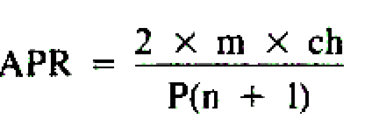
Assume that Juan borrowed $1000 at 10 percent interest. He agreed to pay the principal and interest back in 10 monthly installments. Calculate the APR with the following formula:
Chapter 5
-55-
LAUNCHING A BUSINESS
_______________________________________________________________
Overview:
As you read this chapter look for answers to the following questions:
- What are the challenges and rewards of entrepreneurship?
- What is the role of small business in the American economy?
- What are the advantages and disadvantages of sole proprietorships, partnerships and corporations ?
- How are large corporations organized?
- What are the responsibilities of owning and operating a business?
_______________________________________________________________

Becoming An Entrepreneur.
There are numerous reasons people think about owning a business of their own. Personal independence, unlimited profit potential, the opportunity to work at something that they really love and at hours they choose are some of the reasons people have given for trying entrepreneurship. Many business leaders begin their careers as entrepreneurs after four years of undergraduate college training and even additional graduate school training. Others become successful entrepreneurs without special training.
Entrepreneurial Programs. Many colleges now offer programs that teach students how to start and operate a business. Basic information is combined with hands-on experience and the advice of successful business consultants. These programs help potential entrepreneurs decide whether their own ideas are good and how to follow through with them. With the high rate of business failure, this approach can prevent personal financial losses.

Starting A Small Business.
There are many aids for people who want to start a small business. Through the Small Business Administration, established in 1953, the federal government provides help in the form of literature and counseling through 110 offices in 100 cities throughout the country. Professional small business consultants can also be hired to help potential entrepreneurs make the necessary decisions.
The overall message from people who give advice on the subject is to get all the information you can before you decide.

Risks And Benefits Of Starting A New Business.
Unfortunately, the record shows that two out of three new businesses fail within their first four years. According to a 1982 President's report, The State

Summary:
-54-
The money we spend as consumers comes from wealth or income we earn at our jobs.
A spending plan, or budget, can help people get the most from their incomes. The steps involved in budgeting call for setting goals, estimating income, and planning expenditures and savings. Everyone ought to set aside part of his or her income as savings. It pays to be familiar with the options available to savers and to shop for those products that give you the balance of safety and liquidity you desire.
Insurance provides a way to protect you and your family from emergencies. You can purchase insurance on your life and to pay your medical bills. You can also purchase property insurance to protect your car, home, and other major possessions from damage or theft. Liability insurance protects you if you should injure others or damage their property.
One of the principal services offered by savings institutions and banks is checking accounts. Some of the things that consumers need to know in using and maintaining a checking account are reviewed in the Study Guide.
Credit allows you to purchase the things you want now and pay for them over a specified period of time. Credit can be useful but it does require good character, capital and the capacity to repay the loan. Credit can be expensive. Two of the most important things to look for when shopping for a loan are the finance charge and the APR.
The purpose of advertising is to sell goods and services. While certain advertising techniques benefit consumers, others do not. Consequently, consumers ought to be familiar with the kinds of strategies that advertisers use to sell their products.
The principal responsibility for consumer protection lies with government agencies at the federal, state and local levels. There are, however, a number of organizations, sponsored by the private sector, whose purpose is to protect consumers. These include such well-known institutions as the Better Business Bureau and local Chambers of Commerce.
Because consumers make up the largest economic sector (business and government are the other two), the level of consumer spending has a direct impact on the economy as a whole.
m is the number of payment periods per year (12 if the payments are made monthly; 52 if made weekly).
-49-
ch is the carrying charge or interest (the cost of the loan beyond the amount borrowed).
P is the principal (the amount borrowed).
n is the actual number of payments made.

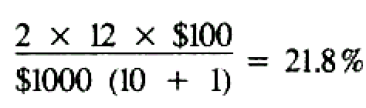
In Juan's case:

Obtaining And Using Credit.
Credit is an arrangement that enables us to receive cash, goods or services now, with the understanding that we will pay for them in the future. Charge accounts, credit cards, installment plans, car loans and household mortgages are some of the best known forms of credit.
Like so many things, credit has its advantages and disadvantages. The principal advantages of credit are:
- Immediate possession. Credit enables us to enjoy goods and services immediately that we might otherwise have had to do without or postpone.
- Flexibility. Credit allows us to time our purchases so as to take advantage of sale items or other bargains even when our funds are low.
- Safety. Credit cards and charge accounts provide a safe and convenient means of carrying our purchasing power with us while we are shopping or travelling.
- Emergency funds. Credit gives us a cushion in an emergency (like an automobile breakdown when money is needed to get back on the road).
- Character reference. The regular payment of bills is recorded in a person's credit history, and this record can be used as a character reference.
Here are some of the disadvantages of buying on credit:
- Overspending. Sometimes, credit cards and charge accounts make it too easy to spend money. Then, as the debts mount, it is often difficult to make the necessary monthly payments.
- Higher cost. It usually costs more to buy on credit than for cash. One reason is that stores offering credit often charge more than those that sell only for cash. Another is that interest or other charges are often added to the cost of goods sold on credit.
- Untimely shopping. Credit shoppers often ignore sales and special prices because they can buy what they want on credit whenever they want it.

Who Can Borrow?
-50-
Lenders expect their money to be repaid along with the interest and other fees they charge for the use of their money. For that reason lenders will investigate the credit history of all loan applicants to determine that they are credit worthy. A credit history is the record of how individuals pay their bills and repay loans.
The Three C’s. In judging an individual's credit worthiness, lenders often look at the "three C's" of credit: character, capacity and capital.
- Character refers to your personal qualities-your honesty and willingness to repay debts. If your record shows you paid your bills on time in the past, lenders will assume you will continue to do so in the future.
- Capacity is a measure of your ability to repay debts. Creditors will want to know about your sources of income, how much you earn and your other financial obligations.
- Capital refers to the things that people own-money in the bank, or property. In general, the more one owns, the easier it will be to repay one's debts. Lenders may also ask that some capital be offered as collateral, some-thing pledged as security for the loan.

How To Establish Credit. Young people recently out of school frequently have difficulty borrowing or buying on credit because they have no credit history. To establish your "credit" you must prove that you are willing and able to handle your financial obligations.
You might, for example, open a charge account in a department store or apply for a gasoline credit card. Prompt payment of the bills on these kinds of accounts will help establish a positive credit rating. If you have a savings account, you may already be eligible to apply for a passbook loan against your balance in that account. Here again, prompt repayment will add to your credit rating. If necessary, it is possible to borrow before you have established a credit rating if you can find a co-signer. A co-signer is a person with an acceptable credit rating who guarantees to repay the loan if you are unable to do so. The point is that a good credit rating is a valuable financial tool. While it may take some time to acquire and maintain, it will increase your financial options. So, go for it.

Learning To Use Advertising.
Advertising is one of our nation's largest industries. In 1986, for example, American business spent over $100 billion to advertise its products. Since consumers are the principal targets of these sales campaigns, we ought to know something about the services advertisers perform, as well as some of the techniques they use.
- The right to be informed. This has been interpreted to mean that consumers have a right to know 1) exactly what it is they are buying; 2) the terms of the sale and any guarantees accompanying it; and 3) the kinds of risks that might accompany the use of a product.
-3-
-53-
- The right to choose. Competition is the backbone of the free enterprise system. For that reason, the federal and state governments have enacted antitrust legislation making attempts to eliminate competition illegal.
- The right to be heard. Both business and government recognize the need to learn what consumers are thinking. Most large firms have special departments that receive and respond to consumer inquiries and complaints. Many firms even provide toll-free "800" numbers to make contacting them easier.
For its part, government regularly conducts public committee hearings on legislation affecting consumers. Anyone can write, call or appear before the committees.
Federal, state and many local governments maintain agencies to assist and protect the consumer.

Business Self-Regulation.
Most business firms recognize that satisfied consumers are the key to financial success. They pay close attention to consumer complaints and do their best to avoid them. In addition, many firms have joined forces to provide a measure of self regulation. Best known of these efforts is the Better Business Bureau (BBB), an international organization that sets standards of business ethics. Local businesses that join BBB agree to maintain fair business practices. Consumers who feel that they have been treated unfairly can call their local BBB to help them resolve their concerns. Chambers of Commerce in local communities also set standards of business ethics.
The Benefits of Advertising. Advertising benefits consumers and the economy in a number of ways:
- It provides us with information about prices, recent improvements in certain goods and services, and the availability of new ones.
-51-
- Advertising often results in lower prices. As you will learn in Chapter 7, large-scale production can reduce costs. By creating mass markets, advertising enables producers to reduce the costs of their products and pass those savings on to the consuming public.
- Advertising stimulates competition, and competition benefits us all. Advertising by one firm puts pressure on others within the industry to do at least as well to attract the consumer's dollar.
- Advertising pays most of the cost of magazines and newspapers, and all of the cost of commercial radio and TV.
- Advertising helps the economy as a whole by stimulating consumer demand. As will be seen in Chapter 12, consumer spending has a direct effect on the health of the economy. Advertising helps to keep that spending at healthy levels.
The Price We Pay for Advertising. Not everyone agrees that advertising benefits the economy. Critics list the following points as its disadvantages:
- The information contained in advertising does not inform and often misleads the consumer.
- Because it costs money to advertise, this cost adds to the price consumers pay.
- Consumers are tempted to spend money for products they do not really need.
- Radio and TV are not really free because the cost of advertising on them is also passed on to the consumer.
Advertising Strategies. Three strategies that have been especially popular with advertisers can be classified as slogans, rational appeals, and emotional appeals.
Slogans. Advertisers often use slogans that sound great but mean little or nothing.
"See Charley Prinz for Your Printing Needs. Remember, Charley Is the Prince of Printers." Charley is not fooling anybody; people know that he is not really a prince. Yet advertisers seem to feel that such slogans, when repeated often enough, do increase sales.
Rational Appeals. Rational appeals rely upon logic or reason to convince the consumer to buy a product.
-52-
"Our Cookies Contain 25% Fewer Calories Than the Next Leading Brand." This is an example of an advertisement that appeals to reason. Ads for health foods, pain relievers and home remedies tend to use this technique.
Emotional Appeals. Emotional appeals rely upon the use of psychology to get the advertiser's message across. The following is a sampling of such strategies:
- Testimonials. These are the advertisements in which famous people claim they use and enjoy a particular product. Ads for sports equipment frequently rely on this strategy.
- The Bandwagon. The bandwagon appeal implies that everybody is using a particular product, and that if you don't, you will be left out. The term derives from the practice, during nineteenth-century circus or political parades, of jumping on or following behind the wagon carrying the band. Soft drink and automobile ads use this appeal.
- Popularity. Some advertisements suggest that simply by using the advertised product you will be popular or find romance. Toothpaste ads showing moments of romance between handsome young men and women are typical of these kinds of campaigns.
Every day you as a consumer are the object of the marketing efforts of American and foreign companies that want your business. The advertising on television and radio and in the newspaper flyers that come to your house are just some of the ways that sales promotions reach you. Can you think of other ways? Most of these marketing strategies represent honest efforts to convince you to buy a product or service. Nevertheless, you are responsible for evaluating advertising directed at you, separating fact from emotion, and deciding whether or not to buy the product.

Government And The Consumer.
Government efforts to protect the consumer can be traced back to George Washington's administration. As life became more complicated, so too did the need for government participation m consumer protection. In more recent times a major leap forward look place during the years of the Kennedy Administration.
In 1962, President Kennedy sent a message to Congress in which he included a "bill of rights" for consumers. These were the right to safety, the right to be informed, the right to choose, and the right to be heard.
- The right to safety. Consumers have a right to be protected from unsafe products. Accordingly, in 1972, Congress created the Consumer Products Safety Commission. The purpose of the commission is to "protect the public from unreasonable risks of injury from consumer products."
Chapter 1
Table of Contents
WHAT IS ECONOMICS? . . . . . . . . . 3

Chapter 2
THE AMERICAN ECONOMIC SYSTEM . . . . 13

Chapter 3
SUPPLY. DEMAND AND MARKET PRICE . . . 27

Chapter 4
THE CONSUMER IN OUR ECONOMY . . . . 40

Chapter 5
LAUNCHING A BUSINESS . . . . . . . . 55

Chapter 6
FINANCING A BUSINESS . . . . . . . . 64

Chapter 7
PRODUCTION AND MARKETING:
THE BUSINESS OF BUSINESS . . . . . . . 72

GLOSSARY . . . . . . . . . . . 86

